ADVANCING DIABETIC DIAGNOSIS THROUGH CNN ARCHITECTURES AND MACHINE LEARNING PREDICTION
TABLE OF CONTENT
SL.NO | TITLE | PAGE.NO
01 | ABSTRACT
02 | EXISTING SYSTEM  2.1 DRAWBACKS
03 | INTRODUCTION  3.1 DATA SCIENCE  3.2 ARTIFICIAL INTELLIGENCE
04 | MACHINE LEARNING
05 | PREPARING DATASET
06 | PROPOSED SYSTEM  6.1 ADVANTAGES
07 | LITERATURE SURVEY
08 | SYSTEM STUDY  8.1 OBJECTIVES  8.2 PROJECT GOAL  8.3 SCOPE OF THE PROJECT
09 | FEASIBILITY STUDY
10 | LIST OF MODULES
11 | PROJECT REQUIREMENTS  11.1 FUNCTIONAL REQUIREMENTS  11.2 NON-FUNCTIONAL REQUIREMENTS
12 | ENVIRONMENT REQUIREMENT
13 | SOFTWARE DESCRIPTION  13.1 ANACONDA NAVIGATOR  13.2 JUPYTER NOTEBOOK
14 | PYTHON
15 | SYSTEM ARCHITECTURE
16 | WORKFLOW DIAGRAM
17 | USECASE DIAGRAM
18 | CLASS DIAGRAM
19 | ACTIVITY DIAGRAM
20 | SEQUENCE DIAGRAM
21 | ER – DIAGRAM
22 | MODULE DESCRIPTION  22.1 MODULE DIAGRAM  22.2 MODULE GIVEN INPUT EXPECTED OUTPUT
23 | DEPLOYMENT
24 | HTML
25 | CSS
26 | CODING
27 | CONCLUSION
28 | FUTURE WORK

LIST OF FIGURES
SL.NO | TITLE | PAGE.NO
01 | SYSTEM ARCHITECTURE
02 | WORKFLOW DIAGRAM
03 | USECASE DIAGRAM
04 | CLASS DIAGRAM
05 | ACTIVITY DIAGRAM
06 | SEQUENCE DIAGRAM
07 | ER – DIAGRAM
08 | MODULE DIAGRAM

LIST OF SYMBOLS
S.NO | NOTATION  NAME | NOTATION | DESCRIPTION
1. | Class | Class Name  -attribute  -attribute  +operation  +operation  +operation  + public  -private  # protected | Represents a collection of similar entities grouped together.
2. | Association | nAME  Class B  Class A  Class B  Class A | Associations represents static relationships between classes. Roles representsthe way the two classes see each other.
3. | Actor | Class A  Class A  Class B  Class B | It aggregates several classes into a single classes.
4. | Aggregation | Class A  Class A  Class B  Class B | Interaction between the system and external environment

5. | Relation  (uses) | uses | Used for additional process communication.
6. | Relation  (extends) | EXTENDS | Extends relationship is used when one use case is similar to another use case but does a bit more.
7. | Communication |  | Communication between various use cases.
8. | State | State | State of the processs.
9. | Initial State |  | Initial state of the object
10. | Final state |  | Final state of the object
11. | Control flow |  | Represents various control flow between the states.
12. | Decision box |  | Represents decision making process from a constraint
13. | Usecase | Usescase | Interact ion between the system and external environment.
14. | Component |  | Represents physical modules which is a collection of components.
15. | Node |  | Represents physical modules which are a collection of components.
16. | Data Process/State |  | A circle in DFD represents a state or process which has been triggered due to some event or acion.
17. | External entity |  | Represents external entities such as keyboard,sensors,etc.
18. | Transition |  | Represents communication that occurs between processes.
19. | Object Lifeline |  | Represents the vertical dimensions that the object communications.
20. | Message | Message | Represents the message exchanged.

ABSTRACT:

Diabetes mellitus remains a significant global health challenge, necessitating accurate and timely diagnostic methods for effective management. This study explores the application of Convolutional Neural Network (CNN) architectures coupled with machine learning techniques to enhance diabetic diagnosis accuracy. Leveraging a diverse dataset of clinical features, including medical history, biochemical markers, and imaging data, our approach aims to extract intricate patterns and correlations indicative of diabetic conditions. The CNN models are trained on large-scale datasets to discern subtle variations in diagnostic indicators, achieving robust classification performance. Validation against standard clinical practices demonstrates promising results, showcasing the potential of deep learning in augmenting diagnostic precision. This research contributes to the evolution of diabetic healthcare by integrating advanced computational methodologies, paving the way for more personalized and effective treatment strategies.

EXISTING SYSTEM:

Leveraging continuous glucose monitoring (CGM) systems, real-time blood glucose (BG) forecasting is essential for proactive interventions, playing a crucial role in enhancing the management of type 1 diabetes (T1D) and type 2 diabetes (T2D). However, developing a model generalized to a population and subsequently embedding it within a microchip of a wearable device presents significant technical challenges. Furthermore, the domain of BG prediction in T2D remains under-explored in the literature. In light of this, we propose a population-specific BG prediction model, leveraging the capabilities of the temporal fusion Transformer (TFT) to adjust predictions based on personal demographic data. Then the trained model is embedded within a system-on-chip, integral to our low-power and low-cost customized wearable device. This device seamlessly communicates with CGM systems through Bluetooth and provides timely BG predictions using edge computing. When evaluated on two publicly available clinical datasets with a total of 124 participants with T1D or T2D, the embedded TFT model consistently demonstrated superior performance, achieving the lowest prediction errors when compared with a range of machine learning baseline methods. Executing the TFT model on our wearable device requires minimal memory and power consumption, enabling continuous decision support for more than 51 days on a single Li-Poly battery charge. These findings demonstrate the significant potential of the proposed TFT model and wearable device in enhancing the quality of life for people with diabetes and effectively addressing real-world challenges.

EXISTING SYSTEM DISADVANTAGES:

Complexity of Embedding: Embedding the TFT model within a system-on-chip (SoC) of a wearable device introduces technical complexities. Ensuring real-time, reliable operation on a low-power and low-cost device requires rigorous optimization and validation processes, which may be resource-intensive.
Battery Life and Maintenance: While claiming more than 51 days of continuous operation on a single Li-Poly battery charge is impressive, real-world conditions such as varying environmental factors and user behaviors could affect battery life. Ensuring consistent performance over extended periods may require frequent recharging or battery replacements.

INTRODUCTION:
Diabetes is a chronic condition affecting millions of people worldwide, characterized by the body's inability to produce or effectively use insulin. Early and accurate diagnosis is critical for managing diabetes and preventing complications such as cardiovascular disease, kidney failure, and neuropathy. Traditional diagnostic methods often rely on blood tests and clinical evaluation, which may not always capture the complexity of the disease. With advancements in technology, deep learning, particularly Convolutional Neural Networks (CNNs), has emerged as a powerful tool in the medical field. This project focuses on leveraging CNN architectures and machine learning techniques to enhance the diagnosis of diabetes. By analyzing complex patterns in medical images and other relevant data, this approach aims to improve the accuracy, efficiency, and early detection of diabetes.

PROPOSED SYSTEM:
In the proposed system for advancing diabetic diagnosis, the integration of CNN architectures and machine learning prediction within Django presents a framework for accurate and timely diagnosis. Utilizing Convolutional Neural Networks (CNNs), the system can effectively analyze medical imaging data such as retinal scans or X-rays, extracting intricate patterns indicative of diabetic complications. These CNN models are trained to discern subtle features that traditional methods might overlook, thereby enhancing diagnostic precision. Moreover, through Django, the system ensures seamless interaction with healthcare providers and patients, facilitating swift data input, analysis, and result dissemination. By leveraging machine learning predictions, the system not only aids in early detection but also supports personalized treatment strategies based on individual patient data, thereby potentially improving outcomes in diabetic care management.

PROPOSED SYSTEM ADVANTAGES:

Enhanced Diagnostic Accuracy: CNNs excel at identifying intricate patterns in medical imaging data, such as retinal scans or X-rays, which can significantly improve the accuracy of detecting diabetic complications compared to traditional methods.
Timely Detection of Diabetic Complications: By leveraging machine learning predictions integrated within Django, the system enables timely detection of diabetic complications. Early identification can lead to prompt intervention and potentially mitigate the progression of the disease.
Efficient Data Handling and Analysis: Django facilitates seamless interaction between healthcare providers and patients, streamlining data input, analysis, and result dissemination. This efficiency not only saves time but also enhances overall workflow in clinical settings.
Support for Healthcare Providers: Healthcare providers can benefit from the system's capabilities to deliver accurate diagnostic insights and support decision-making processes. This support can lead to improved patient care and management of diabetic conditions.

PREPARING THE DATASET:
This dataset contains train and test image records of features extracted, which were then classified into 5classes.

LITERATURE SURVEY
General
A literature review is a body of text that aims to review the critical points of current knowledge on and/or methodological approaches to a particular topic. It is secondary sources and discuss published information in a particular subject area and sometimes information in a particular subject area within a certain time period.
Its ultimate goal is to bring the reader up to date with current literature on a topic and forms the basis for another goal, such as future research that may be needed in the area and precedes a research proposal and may be just a simple summary of sources. Usually, it has an organizational pattern and combines both summary and synthesis.
A summary is a recap of important information about the source, but a synthesis is a re-organization, reshuffling of information. It might give a new interpretation of old material or combine new with old interpretations or it might trace the intellectual progression of the field, including major debates. Depending on the situation, the literature review may evaluate the sources and advise the reader on the most pertinent or relevant of them. Loan default trends have been long studied from a socio-economic stand point.
Most economics surveys believe in empirical modeling of these complex systems in order to be able to predict the loan default rate for a particular individual. The use of machine learning for such tasks is a trend which it is observing now. Some of the survey’s to understand the past and present perspective of loan approval or not.

Review of Literature Survey
Title : DIABETES DIAGNOSIS USING MACHINE LEARNING
Author : Boshra Farajollahi1*, Maysam Mehmannavaz2, Hafez Mehrjoo2, Fateme Moghbeli3 , Mohammad Javad Sayadi
Year : 2021
Diabetes is a disease associated with high levels of glucose in the blood. Diabetes make many kinds of complications, which also leads to a high rate of repeated admission of patients with diabetes. The aim of this study is to diagnose Diabetes with machine learning techniques.
Title: Prediction and Detection of Diabetes using Machine Learning
Author: Olta Llahaa , Amarildo Rista
Year : 2021
Data mining and machine learning have become a vital part of different disease detection and prevention. One of them is diabetes. The purpose of this paper is to evaluate data mining methods and their performances that can be used for analyzing the collected data about the diabetes. We identified the most appropriate data mining methods to analyze the data by comparing them theoretically and practically. Some attributes of this dataset are: Age, Body Mass Index, Insulin, Glucose, etc. Methods are applied on these data to determine their effectiveness in analyzing and preventing diabetes. Evaluations on the data showed that the method with a higher performance is “Decision Tree”. This was achieved by some performance measures, such as the number of instances correctly classified, accuracy, precision, recall and F-measure, that has brought better results compared to other methods. We come to the conclusion that the data mining methods and machine learning contribute to the predictions on the possibility of occurrence of the diabetes.
Title : Diabetic Diagnosis Using Machine Learning as well as Deep Learning Techniques
Author: Somendra Tripathi, Hari Om Sharan, C. S. Raghuvanshi
Year : 2023
A growing incidence of Type II diabetes worldwide has prompted the medical industry to explore solutions for enhancing their medical technology. The fields of machine learning and deep learning are now being actively researched for the development of intelligent and efficient methods for detecting diabetes. This research thoroughly examines and explores the effects of the most recent machine learning and deep learning methods on the detection and categorization of diabetes. The accessibility of diabetes statistics is noted to be restricted. The databases consist of measures obtained from laboratory-based tests and invasive procedures. To develop an efficient solution that is both cost-effective and high-performing, it is necessary to do research on anthropometric measures and non-invasive examinations. Multiple studies have shown the potential to develop detection models using anthropometric measures and non-invasive medical indications. This research examined the effects of oversampling strategies and data decrease in dimensionality via the selection of features.
Title : Diabetes Prediction using Machine Learning Techniques
Author: Mitushi Soni, Sunita varma
Year : 2020
Diabetes is an illness caused because of high glucose level in a human body. Diabetes should not be ignored if it is untreated then Diabetes may cause some major issues in a person like: heart related problems, kidney problem, blood pressure, eye damage and it can also affects other organs of human body. Diabetes can be controlled if it is predicted earlier. To achieve this goal this project work we will do early prediction of Diabetes in a human body or a patient for a higher accuracy through applying, Various Machine Learning Techniques. Machine learning techniques Provide better result for prediction by constructing models from datasets collected from patients. In this work we will use Machine Learning Classification and ensemble techniques on a dataset to predict diabetes. Which are K-Nearest Neighbor (KNN), Logistic Regression (LR), Decision Tree (DT), Support Vector Machine (SVM), Gradient Boosting (GB) and Random Forest (RF). The accuracy is different for every model when compared to other models. The Project work gives the accurate or higher accuracy model shows that the model is capable of predicting diabetes effectively. Our Result shows that Random Forest achieved higher accuracy compared to other machine learning techniques.
Title : Machine Learning for Early Diabetes Detection and Diagnosis
Author: Sofiene Mansouri1* , Souhaila Boulares2 , and Souhir Chabchoub3
Year : 2023
In this work, a machine learning (ML)-based e-diagnostic system is suggested specifically for the detection of gestational diabetes mellitus (GDM). Reviewing recent GDM data and outlining the intimate connection between GDM and prediabetic conditions, as well as the potential for future declines in insulin resistance and the emergence of overt Type 2 diabetes, were our goals. The present study explores the application of the K-nearest neighbors (KNN) algorithm to project diabetes diagnosis on the widely-used Pima Indians Diabetes database. The KNN algorithm, a non-parametric, instance-based learning method, was employed to classify individuals as either diabetic or non-diabetic, our objectives were to evaluate the algorithm’s ability to make accurate predictions and explore factors influencing its performance. The study commenced with data preprocessing, including handling missing values, feature scaling, and data splitting into training and testing sets. The KNN classifier was trained and tested using these best-fit parameters. The results of this study revealed a model with an accuracy of approximately 0.76 in predicting diabetes diagnosis. This study looked at the various machine-learning approaches for diabetes patient classification, including recall, accuracy, precision, and F1-score. The study discusses the significance of hyperparameter tuning, data preprocessing, and imbalanced data handling in achieving optimal KNN model performance. Lastly, this study shows how the KNN algorithm may be used to project diabetes using the Pima Indians Diabetes Database. The findings suggest that KNN can serve as a viable tool in the early detection of diabetes, paving the way for more extensive applications in healthcare and predictive modelling.

SYSTEM STUDY:

Project Goals:

Load the data
- Loading the given dataset
- Import required libraries packages

Pre-process the data
- Reshape, data augmentations

Define model
- Sequential or Functional
- Number of layers to be used, Number of nodes to be used in the model, Evaluation metrics

Compile the model
- Define loss function, optimizer, weights and bias

Fit the model
- Train data, Test data, epoch, Batch size.

Aim:
The aim of this project is to advance the diagnosis of diabetes by developing a deep learning model using Convolutional Neural Networks (CNNs) and machine learning algorithms. The goal is to enhance the accuracy and early detection of diabetes through automated analysis of medical data.

Objectives:
  - To develop a CNN-based model for the accurate diagnosis of diabetes using medical images and related data.
  - To enhance the early detection of diabetes through automated analysis, reducing the dependency on traditional diagnostic methods.
  - To evaluate the performance of the CNN model using standard metrics and compare it with existing diagnostic methods.
  - To integrate the model into a user-friendly diagnostic system that can be utilized in clinical settings.
  - To validate the model across diverse datasets to ensure robustness and adaptability to different patient populations.
Scope:
- Data Collection: Gathering relevant medical data, including images and clinical records, related to diabetic patients.
- Model Development: Designing and training CNN architectures to analyze the collected data.
- Model Evaluation: Assessing the performance of the model using metrics such as accuracy, sensitivity, and specificity.
- Integration: Implementing the model within a practical diagnostic system that can assist healthcare professionals in decision-making.
- Validation: Testing the model's effectiveness on a variety of datasets to ensure generalizability and reliability.

OUTLINE OF THE PROJECT

Overview of the system:
- Define a problem
- Gathering image data set
- Evaluating algorithms
- Detecting results
The steps involved in Building the data model is depicted below
Data collection (Splitting Training set & Test) set)

Pre Processing (Sequential)

Building classification Model

Prediction (diagnosis of diabetes)

Fig: data flow diagram for CNN model
PROJECT REQUIREMENTS
General:
Requirements are the basic constrains that are required to develop a system. Requirements are collected while designing the system. The following are the requirements that are to be discussed.
1. Functional requirements
2. Non-Functional requirements
3. Environment requirements
A. Hardware requirements
B. software requirements
Functional requirements: The software requirements specification is a technical specification of requirements for the software product. It is the first step in the requirements analysis process. It lists requirements of a particular software system. The following details to follow the special libraries like tensorflow, keras, matplotlib.
Non-Functional Requirements:
Process of functional steps,
- Problem define
- Preparing data
- Evaluating algorithm
- Improving results
- Prediction the result

Environment Requirements:
Framework : Keras.
Software Requirements:
- Operating System : Windows / Linux
- Simulation Tool : Anaconda with Jupyter Notebook
- Language : Python
Hardware requirements:
- Processor : Intel i3
- Hard disk : minimum 400 GB
- RAM : minimum 4 GB
FEASIBILITY STUDY
Splitting the dataset:
The data use is usually split into training data and test data. The training set contains a known output and the model learns on this data in order to be generalized to other data later on. It has the test dataset (or subset) in order to test our models and it will do this using Tensor flow library in Python using the Keras method.

Construction of a Detecting Model:

Deep learning needs data gathering have lot of past image data’s. Training and testing this model working and predicting correctly.
Data Gathering
CNN Algorithm
Train model

Prediction
Test model

Fig: Steps of dataflow diagram

DESIGN ARCHITECTURE

General

Design is meaningful engineering representation of something that is to be built. Software design is a process design is the perfect way to accurately translate requirements in to a finished software product. Design creates a representation or model, provides detail about software data structure, architecture, interfaces and components that are necessary to implement a system.

Data Flow Diagram:
Image Details
Test dataset
Preprocessing
Prediction (diagnosis of diabetes)

CNN Algorithm
Training dataset

Fig: Process of dataflow diagram

A data flow diagram (DFD) is a graphical representation of the "flow" of data through an information system, modeling its process aspects. A DFD is often used as a preliminary step to create an overview of the system without going into great detail, which can later be elaborated. DFDs can also be used for the visualization of data processing (structured design). A DFD shows what kind of information will be input to and output from the system, how the data will advance through the system, and where the data will be stored. It does not show information about process timing or whether processes will operate in sequence or in parallel, unlike a traditional structured flowchart which focuses on control flow, or a UML activity workflow diagram, which presents both control and data flows as a unified model. Data flow diagrams are also known as bubble charts. DFD is a designing tool used in the top down approach to Systems Design. Symbols and Notations Used in DFDs Using any convention’s DFD rules or guidelines, the symbols depict the four components of data flow diagrams.
External entity: an outside system that sends or receives data, communicating with the system being diagrammed. They are the sources and destinations of information entering or leaving the system. They might be an outside organization or person, a computer system or a business system. They are also known as terminators, sources and sinks or actors. They are typically drawn on the edges of the diagram.
Process: any process that changes the data, producing an output. It might perform computations, or sort data based on logic, or direct the data flow based on business rules.
Data store: files or repositories that hold information for later use, such as a database table or a membership form.
Data flow: the route that data takes between the external entities, processes and data stores. It portrays the interface between the other components and is shown with arrows, typically labeled with a short data name, like “Billing details.”
DFD levels and layers A data flow diagram can dive into progressively more detail by using levels and layers, zeroing in on a particular piece. DFD levels are numbered 0, 1 or 2, and occasionally go to even Level 3 or beyond. The necessary level of detail depends on the scope of what you are trying to accomplish. DFD Level 0 is also called a Context Diagram. It’s a basic overview of the whole system or process being analyzed or modeled. It’s designed to be an at-a-glance view, showing the system as a single high-level process, with its relationship to external entities. It should be easily understood by a wide audience, including stakeholders, business analysts, data analysts and developers.
System Architecture:
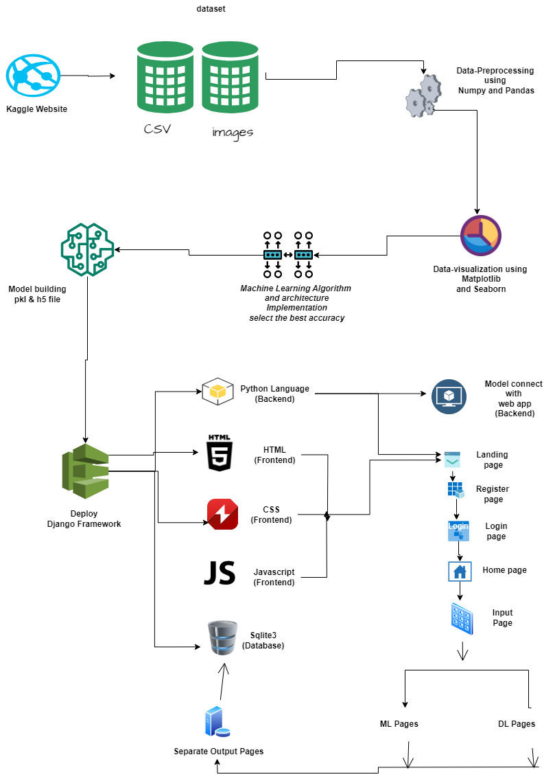

Work flow diagram:

Source images

Testing Dataset
Training Dataset

CNN algorithm

Prediction (diagnosis of diabetes)

Fig: Workflow Diagram

USECASE DIAGRAM:
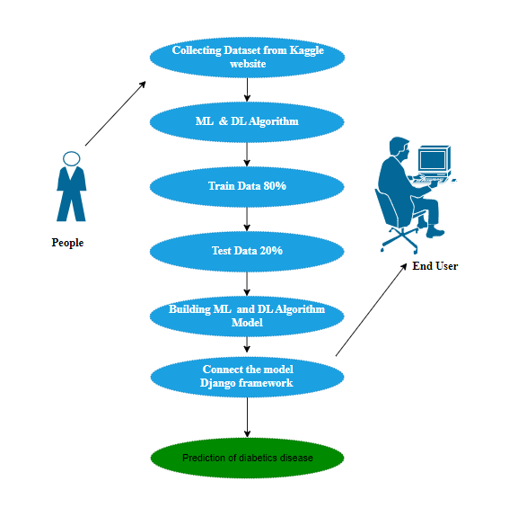

Use case diagrams are considered for high level requirement analysis of a system. So when the requirements of a system are analyzed the functionalities are captured in use cases. So, it can say that uses cases are nothing but the system functionalities written in an organized manner.

CLASS DIAGRAM:
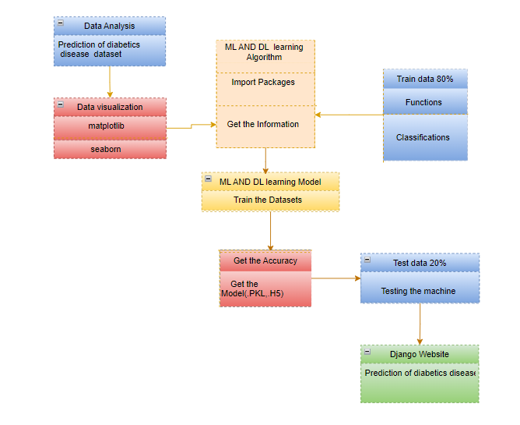
Class diagram is basically a graphical representation of the static view of the system and represents different aspects of the application. So a collection of class diagrams represent the whole system. The name of the class diagram should be meaningful to describe the aspect of the system. Each element and their relationships should be identified in advance Responsibility (attributes and methods) of each class should be clearly identified for each class minimum number of properties should be specified and because, unnecessary properties will make the diagram complicated. Use notes whenever required to describe some aspect of the diagram and at the end of the drawing it should be understandable to the developer/coder. Finally, before making the final version, the diagram should be drawn on plain paper and rework as many times as possible to make it correct.

ACTIVITY DIAGRAM:
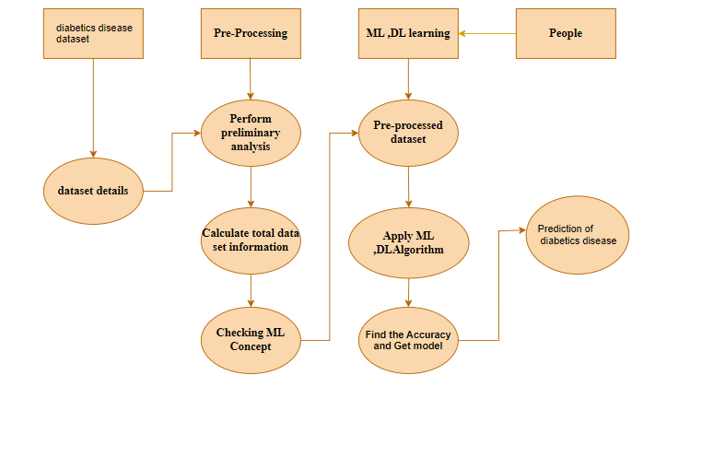

Activity is a particular operation of the system. Activity diagrams are not only used for visualizing dynamic nature of a system but they are also used to construct the executable system by using forward and reverse engineering techniques. The only missing thing in activity diagram is the message part. It does not show any message flow from one activity to another. Activity diagram is some time considered as the flow chart. Although the diagrams looks like a flow chart but it is not. It shows different flow like parallel, branched, concurrent and single.

SEQUENCE DIAGRAM:
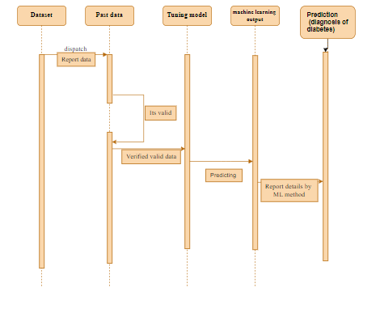
Sequence diagrams model the flow of logic within your system in a visual manner, enabling you both to document and validate your logic, and are commonly used for both analysis and design purposes. Sequence diagrams are the most popular UML artifact for dynamic modelling, which focuses on identifying the behaviour within your system. Other dynamic modelling techniques include activity diagramming, communication diagramming, timing diagramming, and interaction overview diagramming. Sequence diagrams, along with class diagrams and physical data models are in my opinion the most important design-level models for modern business application development.

ER DIAGRAM:

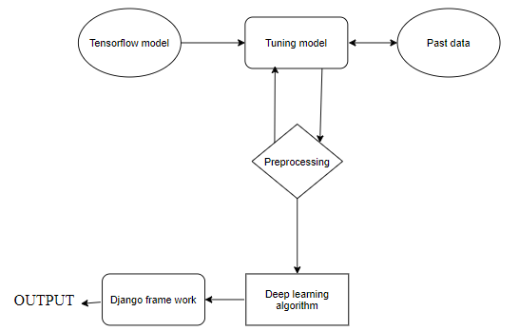

An entity relationship diagram (ERD), also known as an entity relationship model, is a graphical representation of an information system that depicts the relationships among people, objects, places, concepts or events within that system. An ERD is a data modeling technique that can help define business processes and be used as the foundation for a relational database. Entity relationship diagrams provide a visual starting point for database design that can also be used to help determine information system requirements throughout an organization. After a relational database is rolled out, an ERD can still serve as a referral point, should any debugging or business process re-engineering be needed later.

COLLABORATION DIAGRAM:

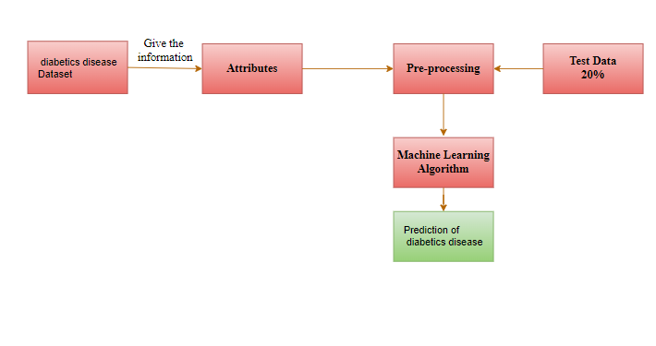

A collaboration diagram show the objects and relationships involved in an interaction, and the sequence of messages exchanged among the objects during the interaction.
The collaboration diagram can be a decomposition of a class, class diagram, or part of a class diagram.it can be the decomposition of a use case, use case diagram, or part of a use case diagram.
The collaboration diagram shows messages being sent between classes and object (instances). A diagram is created for each system operation that relates to the current development cycle (iteration).

SOFTWARE DESCRIPTION
Anaconda is a free and open-source distribution of the Python and R programming languages for scientific computing (data science, machine learning applications, large-scale data processing, predictive analytics, etc.), that aims to simplify package management and deployment. Package versions are managed by the package management system “Conda”. The Anaconda distribution is used by over 12 million users and includes more than 1400 popular data-science packages suitable for Windows, Linux, and MacOS. So, Anaconda distribution comes with more than 1,400 packages as well as the Conda package and virtual environment manager called Anaconda Navigator and it eliminates the need to learn to install each library independently. The open source packages can be individually installed from the Anaconda repository with the conda install command or using the pip install command that is installed with Anaconda. Pip packages provide many of the features of conda packages and in most cases they can work together. Custom packages can be made using the conda build command, and can be shared with others by uploading them to Anaconda Cloud, PyPI or other repositories. The default installation of Anaconda2 includes Python 2.7 and Anaconda3 includes Python 3.7. However, you can create new environments that include any version of Python packaged with conda.

ANACONDA NAVIGATOR:
Anaconda Navigator is a desktop graphical user interface (GUI) included in Anaconda® distribution that allows you to launch applications and easily manage conda packages, environments, and channels without using command-line commands. Navigator can search for packages on Anaconda.org or in a local Anaconda Repository.
Anaconda. Now, if you are primarily doing data science work, Anaconda is also a great option. Anaconda is created by Continuum Analytics, and it is a Python distribution that comes preinstalled with lots of useful python libraries for data science.
Anaconda is a distribution of the Python and R programming languages for scientific computing (data science, machine learning applications, large-scale data processing, predictive analytics, etc.), that aims to simplify package management and deployment.
In order to run, many scientific packages depend on specific versions of other packages. Data scientists often use multiple versions of many packages and use multiple environments to separate these different versions.
The command-line program conda is both a package manager and an environment manager. This helps data scientists ensure that each version of each package has all the dependencies it requires and works correctly.
Navigator is an easy, point-and-click way to work with packages and environments without needing to type conda commands in a terminal window. You can use it to find the packages you want, install them in an environment, run the packages, and update them – all inside Navigator.

The following applications are available by default in Navigator:
- JupyterLab
- Jupyter Notebook
- Spyder
- PyCharm
- VSCode
- Glueviz
- Orange 3 App
- RStudio
- Anaconda Prompt (Windows only)
- Anaconda PowerShell (Windows only)

Anaconda Navigator is a desktop graphical user interface (GUI) included in Anaconda distribution.
Navigator allows you to launch common Python programs and easily manage conda packages, environments, and channels without using command-line commands. Navigator can search for packages on Anaconda Cloud or in a local Anaconda Repository.
Anaconda comes with many built-in packages that you can easily find with conda list on your anaconda prompt. As it has lots of packages (many of which are rarely used), it requires lots of space and time as well. If you have enough space, time and do not want to burden yourself to install small utilities like JSON, YAML, you better go for Anaconda.
JUPYTER NOTEBOOK:
This website acts as “meta” documentation for the Jupyter ecosystem. It has a collection of resources to navigate the tools and communities in this ecosystem, and to help you get started.
Project Jupyter is a project and community whose goal is to "develop open-source software, open-standards, and services for interactive computing across dozens of programming languages". It was spun off from IPython in 2014 by Fernando Perez.
- Launch the jupyter notebook app
- In the Notebook Dashboard navigate to find the notebook: clicking on its name will open it in a new browser tab.
- Click on the menu Help -> User Interface Tour for an overview of the Jupyter Notebook App user interface.
- You can run the notebook document step-by-step (one cell a time) by pressing shift + enter.
- You can run the whole notebook in a single step by clicking on the menu Cell -> Run All.
- To restart the kernel (i.e. the computational engine), click on the menu Kernel -> Restart. This can be useful to start over a computation from scratch (e.g. variables are deleted, open files are closed, etc…).

Purpose: To support interactive data science and scientific computing across all programming languages.

File Extension: An IPYNB file is a notebook document created by Jupyter Notebook, an interactive computational environment that helps scientists manipulate and analyze data using Python.

JUPYTER Notebook App: The Jupyter Notebook App is a server-client application that allows editing and running notebook documents via a web browser. The Jupyter Notebook App can be executed on a local desktop requiring no internet access (as described in this document) or can be installed on a remote server and accessed through the internet.
In addition to displaying/editing/running notebook documents, the Jupyter Notebook App has a “Dashboard” (Notebook Dashboard), a “control panel” showing local files and allowing to open notebook documents or shutting down their kernels.

kernel: A notebook kernel is a “computational engine” that executes the code contained in a Notebook document. The ipython kernel, referenced in this guide, executes python code. Kernels for many other languages exist (official kernels).
When you open a Notebook document, the associated kernel is automatically launched. When the notebook is executed (either cell-by-cell or with menu Cell -> Run All), the kernel performs the computation and produces the results. Depending on the type of computations, the kernel may consume significant CPU and RAM. Note that the RAM is not released until the kernel is shut-down

Notebook Dashboard: The Notebook Dashboard is the component which is shown first when you launch Jupyter Notebook App. The Notebook Dashboard is mainly used to open notebook documents, and to manage the running kernels (visualize and shutdown).
The Notebook Dashboard has other features similar to a file manager, namely navigating folders and renaming/deleting files

Working Process:
- Download and install anaconda and get the most useful package for machine learning in Python.
- Load a dataset and understand its structure using statistical summaries and data visualization.
- Machine learning models, pick the best and build confidence that the accuracy is reliable.

Python is a popular and powerful interpreted language. Unlike R, Python is a complete language and platform that you can use for both research and development and developing production systems. There are also a lot of modules and libraries to choose from, providing multiple ways to do each task. It can feel overwhelming.

The best way to get started using Python for machine learning is to complete a project.
- It will force you to install and start the Python interpreter (at the very least).
- It will give you a bird’s eye view of how to step through a small project.
- It will give you confidence, maybe to go on to your own small projects.

When you are applying machine learning to your own datasets, you are working on a project. A machine learning project may not be linear, but it has a number of well-known steps:
- Define Problem.
- Prepare Data.
- Evaluate Algorithms.
- Improve Results.
- Present Results.

The best way to really come to terms with a new platform or tool is to work through a machine learning project end-to-end and cover the key steps. Namely, from loading data, summarizing data, evaluating algorithms and making some predictions.
Here is an overview of what we are going to cover:
- Installing the Python anaconda platform.
- Loading the dataset.
- Summarizing the dataset.
- Visualizing the dataset.
- Evaluating some algorithms.
- Making some predictions.

METHODOLOGY
Preprocessing and Training the model (CNN): The dataset is preprocessed such as Image reshaping, resizing and conversion to an array form. Similar processing is also done on the test image. A dataset consisting of about 5 different diagnosis of diabetes is obtained, out of which any image can be used as a test image for the software.

CNN Weights

(Diagnosis of
diabetes)
Raw image
Build a sequential model

CNN train

The train dataset is used to train the model (CNN) so that it can identify the test image and the disease it has CNN has different layers that are Dense, Dropout, Activation, Flatten, Convolution2D, and MaxPooling2D. After the model is trained successfully, the software can identify the Automobile parts Classification image contained in the dataset. After successful training and preprocessing, comparison of the test image and trained model takes place to predict the diabetes

ARCHITECTURE OF CNN
CONVOLUTIONAL NEURAL NETWORK:
A Convolutional neural network (CNN) is one type of Artificial Neural Network. A Convolutional neural network (CNN) is a neural network that has one or more convolutional layers and are used mainly for image processing, classification, segmentation and also for other auto correlated data.

Models API:
There are three ways to create Keras models:
• The Sequential model, which is very straightforward (a simple list of layers), but is limited to single-input, single-output stacks of layers (as the name gives away).
• The Functional API, which is an easy-to-use, fully-featured API that supports arbitrary model architectures. For most people and most use cases, this is what you should be using. This is the Keras "industry strength" model.
• Model subclassing, where you implement everything from scratch on your own. Use this if you have complex, out-of-the-box research use cases.

Types of Keras Models
Models in keras are available in two types:
• Keras Sequential Model
• Keras Functional API

1. Sequential Model in Keras
It allows us to create models layer by layer in sequential order. But it does not allow us to create models that have multiple inputs or outputs.
It is best for simple stack of layers which have 1 input tensor and 1 output tensor.
This model is not suited when any of the layer in the stack has multiple inputs or outputs. Even if we want non-linear topology, it is not suited.

2. Functional API in Keras
It provides more flexibility to define a model and add layers in keras. Functional API allows us to create models that have multiple input or output.
It also allows us to share these layers. In other words. we can make graphs of layers using Keras functional API.
As functional API is a data structure, it is easy to save it as a single file that helps in recreating the exact model without having the original code. Also its easy to model the graph here and access its nodes as well.
TYPES OF CNN:

- MAUAL NET
- LE NET

LIST OF MODULES
- Data Pre-processing
- Data Analysis of Visualization
- GRADIENT BOOSTING
- Manual Net
- LeeNet
- Deploy
MODULE DESCRIPTION:
Data Pre-processing
Validation techniques in machine learning are used to get the error rate of the Machine Learning (ML) model, which can be considered as close to the true error rate of the dataset. If the data volume is large enough to be representative of the population, you may not need the validation techniques. However, in real-world scenarios, to work with samples of data that may not be a true representative of the population of given dataset. To finding the missing value, duplicate value and description of data type whether it is float variable or integer. The sample of data used to provide an unbiased evaluation of a model fit on the training dataset while tuning model hyper parameters.
The evaluation becomes more biased as skill on the validation dataset is incorporated into the model configuration. The validation set is used to evaluate a given model, but this is for frequent evaluation. It as machine learning engineers use this data to fine-tune the model hyper parameters. Data collection, data analysis, and the process of addressing data content, quality, and structure can add up to a time-consuming to-do list. During the process of data identification, it helps to understand your data and its properties; this knowledge will help you choose which algorithm to use to build your model.
A number of different data cleaning tasks using Python’s Pandas library and specifically, it focus on probably the biggest data cleaning task, missing values and it able to more quickly clean data. It wants to spend less time cleaning data, and more time exploring and modeling.
Some of these sources are just simple random mistakes. Other times, there can be a deeper reason why data is missing. It’s important to understand these different types of missing data from a statistics point of view. The type of missing data will influence how to deal with filling in the missing values and to detect missing values, and do some basic imputation and detailed statistical approach for dealing with missing data. Before, joint into code, it’s important to understand the sources of missing data. Here are some typical reasons why data is missing:
- User forgot to fill in a field.
- Data was lost while transferring manually from a legacy database.
- There was a programming error.
- Users chose not to fill out a field tied to their beliefs about how the results would be used or interpreted.

Variable identification with Uni-variate, Bi-variate and Multi-variate analysis:
- import libraries for access and functional purpose and read the given dataset
- General Properties of Analyzing the given dataset
- Display the given dataset in the form of data frame
- show columns
- shape of the data frame
- To describe the data frame
- Checking data type and information about dataset
- Checking for duplicate data
- Checking Missing values of data frame
- Checking unique values of data frame
- Checking count values of data frame
- Rename and drop the given data frame
- To specify the type of values
- To create extra columns

Data Validation/ Cleaning/Preparing Process
Importing the library packages with loading given dataset. To analyzing the variable identification by data shape, data type and evaluating the missing values, duplicate values. A validation dataset is a sample of data held back from training your model that is used to give an estimate of model skill while tuning models and procedures that you can use to make the best use of validation and test datasets when evaluating your models. Data cleaning / preparing by rename the given dataset and drop the column etc. to analyze the uni-variate, bi-variate and multi-variate process. The steps and techniques for data cleaning will vary from dataset to dataset. The primary goal of data cleaning is to detect and remove errors and anomalies to increase the value of data in analytics and decision making.
MODULE DIAGRAM
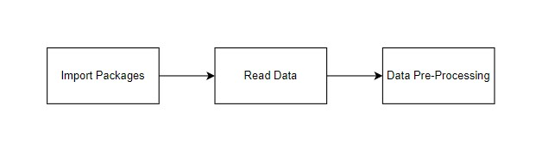
GIVEN INPUT EXPECTED OUTPUT
input : data
output : removing noisy data
Exploration data analysis of visualization
Data visualization is an important skill in applied statistics and machine learning. Statistics does indeed focus on quantitative descriptions and estimations of data. Data visualization provides an important suite of tools for gaining a qualitative understanding. This can be helpful when exploring and getting to know a dataset and can help with identifying patterns, corrupt data, outliers, and much more. With a little domain knowledge, data visualizations can be used to express and demonstrate key relationships in plots and charts that are more visceral and stakeholders than measures of association or significance. Data visualization and exploratory data analysis are whole fields themselves and it will recommend a deeper dive into some the books mentioned at the end.
Sometimes data does not make sense until it can look at in a visual form, such as with charts and plots. Being able to quickly visualize of data samples and others is an important skill both in applied statistics and in applied machine learning. It will discover the many types of plots that you will need to know when visualizing data in Python and how to use them to better understand your own data.
- How to chart time series data with line plots and categorical quantities with bar charts.
- How to summarize data distributions with histograms and box plots.

Pre-processing refers to the transformations applied to our data before feeding it to the algorithm. Data Pre-processing is a technique that is used to convert the raw data into a clean data set. In other words, whenever the data is gathered from different sources it is collected in raw format which is not feasible for the analysis. To achieving better results from the applied model in Machine Learning method of the data has to be in a proper manner. Some specified Machine Learning model needs information in a specified format, for example, Random Forest algorithm does not support null values. Therefore, to execute random forest algorithm null values have to be managed from the original raw data set. And another aspect is that data set should be formatted in such a way that more than one Machine Learning and Deep Learning algorithms are executed in given dataset.

MODULE DIAGRAM
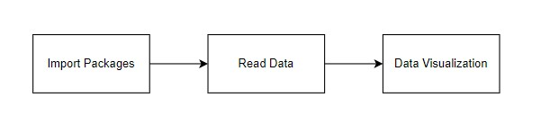

GIVEN INPUT EXPECTED OUTPUT
input : data
output : visualized data

Prediction result by accuracy:
Algorithm also uses a linear equation with independent predictors to predict a value. The predicted value can be anywhere between negative infinity to positive infinity. It need the output of the algorithm to be classified variable data. Higher accuracy predicting result is logistic regression model by comparing the best accuracy.

False Positives (FP): A person who will pay predicted as defaulter. When actual class is no and predicted class is yes. E.g. if actual class says this passenger did not survive but predicted class tells you that this passenger will survive.
False Negatives (FN): A person who default predicted as payer. When actual class is yes but predicted class in no. E.g. if actual class value indicates that this passenger survived and predicted class tells you that passenger will die.
True Positives (TP): A person who will not pay predicted as defaulter. These are the correctly predicted positive values which means that the value of actual class is yes and the value of predicted class is also yes. E.g. if actual class value indicates that this passenger survived and predicted class tells you the same thing.
True Negatives (TN): A person who default predicted as payer. These are the correctly predicted negative values which means that the value of actual class is no and value of predicted class is also no. E.g. if actual class says this passenger did not survive and predicted class tells you the same thing.

True Positive Rate (TPR) = TP / (TP + FN)
False Positive Rate (FPR) = FP / (FP + TN)

Accuracy: The Proportion of the total number of predictions that is correct otherwise overall how often the model predicts correctly defaulters and non-defaulters.

Accuracy calculation:
Accuracy = (TP + TN) / (TP + TN + FP + FN)
Accuracy is the most intuitive performance measure and it is simply a ratio of correctly predicted observation to the total observations. One may think that, if we have high accuracy then our model is best. Yes, accuracy is a great measure but only when you have symmetric datasets where values of false positive and false negatives are almost same.

Precision: The proportion of positive predictions that are actually correct.
Precision = TP / (TP + FP)
Precision is the ratio of correctly predicted positive observations to the total predicted positive observations. The question that this metric answer is of all passengers that labelled as survived, how many actually survived? High precision relates to the low false positive rate. We have got 0.788 precision which is pretty good.

Recall: The proportion of positive observed values correctly predicted. (The proportion of actual defaulters that the model will correctly predict)
Recall = TP / (TP + FN)
Recall (Sensitivity) - Recall is the ratio of correctly predicted positive observations to the all observations in actual class - yes.

F1 Score is the weighted average of Precision and Recall. Therefore, this score takes both false positives and false negatives into account. Intuitively it is not as easy to understand as accuracy, but F1 is usually more useful than accuracy, especially if you have an uneven class distribution. Accuracy works best if false positives and false negatives have similar cost. If the cost of false positives and false negatives are very different, it’s better to look at both Precision and Recall.

General Formula:
F- Measure = 2TP / (2TP + FP + FN)
F1-Score Formula:
F1 Score = 2*(Recall * Precision) / (Recall + Precision)

ALGORITHM AND TECHNIQUES
Algorithm Explanation
In machine learning and statistics, classification is a supervised learning approach in which the computer program learns from the data input given to it and then uses this learning to classify new observation. This data set may simply be bi-class (like identifying whether the person is male or female or that the mail is spam or non-spam) or it may be multi-class too. Some examples of classification problems are: speech recognition, handwriting recognition, bio metric identification, document classification etc. In Supervised Learning, algorithms learn from labelled data. After understanding the data, the algorithm determines which label should be given to new data based on pattern and associating the patterns to the unlabelled new data.

Used Python Packages:
sklearn:
  - In python, sklearn is a machine learning package which include a lot of ML algorithms.
  - Here, we are using some of its modules like train_test_split, DecisionTreeClassifier or Logistic Regression and accuracy_score.
NumPy:
  - It is a numeric python module which provides fast maths functions for calculations.
  - It is used to read data in numpy arrays and for manipulation purpose.
Pandas:
  - Used to read and write different files.
  - Data manipulation can be done easily with data frames.

Matplotlib:
  - Data visualization is a useful way to help with identify the patterns from given dataset.
  - Data manipulation can be done easily with data frames.

GRADIENT BOOSTING:
Gradient Boosting is another powerful ensemble learning technique used for both classification and regression tasks. It builds a series of weak learners (typically decision trees) sequentially, with each tree trying to correct the errors of the combined ensemble so far. One of the most popular implementations of Gradient Boosting is the Gradient Boosting Machine (GBM) or its variants like XGBoost, LightGBM, and CatBoost.
Here's an explanation of how the Gradient Boosting algorithm works:
Building Weak Learners:
The algorithm starts by fitting a simple model (weak learner) to the dataset. For regression tasks, this could be a decision tree with just a few levels, and for classification tasks, it could be a shallow decision tree with two classes.
Residual Calculation:
The algorithm calculates the residuals or errors of the current model's predictions compared to the true values in the training set. These residuals represent the mistakes made by the current model.
Fitting the Next Weak Learner:
A new weak learner is then fitted to the residuals, focusing on capturing the patterns or information that the previous model didn't handle well. The objective is to reduce the residuals or errors.
Weighted Combination:
The predictions from all the weak learners are combined with weights, where the weights are determined during the training process. The weights are assigned based on the performance of each weak learner—better-performing models receive higher weights.
Learning Rate:
A learning rate is introduced to control the contribution of each weak learner to the ensemble. It scales the predictions from each weak learner before combining them with the ensemble's current predictions. A lower learning rate makes the algorithm more robust but requires more trees to achieve high accuracy.
Iteration:
Steps 2-5 are repeated for a predefined number of iterations or until a stopping criterion is met. Each iteration focuses on correcting the errors made by the combined ensemble so far.
Advantages of Gradient Boosting:
High predictive accuracy.
Handles both regression and classification tasks.
Can capture complex relationships in the data.
Disadvantages:
May require careful tuning of hyperparameters.
Can be computationally expensive and time-consuming.
Popular Implementations:
XGBoost (Extreme Gradient Boosting): An efficient and scalable implementation of Gradient Boosting.
LightGBM: A fast, distributed, high-performance implementation with support for large datasets.
CatBoost: A version of Gradient Boosting that is designed to work well with categorical features.
Gradient Boosting is a powerful algorithm, and its variants have been widely adopted in various machine learning competitions and real-world applications due to their excellent performance and flexibility.

MODULE DIAGRAM
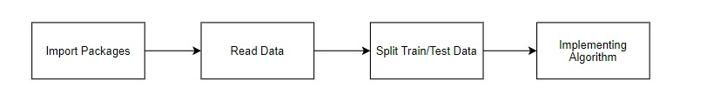

GIVEN INPUT EXPECTED OUTPUT
input : data
output : getting accuracy

MANUAL ARCHITECTURE:
Manual Architecture is a novel convolutional neural network designed to address specific challenges in machine learning and computer vision tasks. Leveraging a carefully crafted structure, ManuLAL aims to optimize both model performance and computational efficiency.
Architecture of Manual:
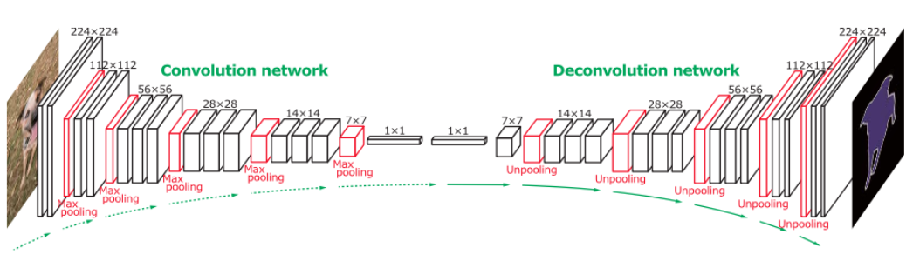
Modular Feature Extraction Blocks:
ManuLAL incorporates modular feature extraction blocks, each consisting of a combination of depthwise separable convolutions and dilated convolutions. This design choice allows the network to capture multi-scale features efficiently, enabling robust representation learning.
Attention Mechanism:
An attention mechanism is integrated into ManuLAL to enhance the focus on salient regions within the input data. This attention mechanism dynamically adjusts the weights assigned to different parts of the feature maps, promoting more effective feature learning.
Residual Connections:
To facilitate gradient flow and encourage the learning of residual features, Manual employs residual connections. These connections enable the network to better capture intricate patterns and ease the training process, contributing to overall model stability.
Adaptive Pooling Layers:
Manual features adaptive pooling layers that dynamically adjust their pooling size based on the input dimensions. This adaptability ensures that spatial information is preserved, particularly crucial for tasks where fine-grained details are essential.
Cross-Modal Fusion:
In addressing multi-modal learning challenges, Manual introduces cross-modal fusion layers. These layers enable the network to seamlessly integrate information from different modalities, promoting a holistic understanding of complex input data.
Sparse Connections:
To optimize computational resources, Manual incorporates sparse connections within the network architecture. This strategic sparsity enhances training efficiency without compromising the model's ability to capture intricate features.
Flexible Activation Functions:
Manual provides flexibility in activation functions, allowing users to choose from a variety of non-linearities based on the task requirements. This adaptability empowers researchers and practitioners to tailor the network to specific use cases.
Practical Applications:
The Manual Architecture is designed with versatility in mind, making it suitable for a wide range of applications, including image classification, object detection, and semantic segmentation. Its modular design and attention to efficiency make it particularly well-suited for deployment in resource-constrained environments.
Community Integration and Contributions:
As an open-source initiative, Manual encourages community involvement and contributions. Researchers and developers can extend the architecture, experiment with different modules, and collaborate to further enhance its capabilities.
Manual Architecture represents a forward-thinking approach to convolutional neural networks, emphasizing modularity, efficiency, and adaptability. Its unique features make it a promising candidate for various machine learning tasks, contributing to the evolving landscape of deep learning architectures.
LENET:
The LeNet architecture is a pioneering convolutional neural network (CNN) architecture developed by Yann LeCun and his colleagues in the early 1990s. It played a crucial role in the advancement of deep learning and was specifically designed for handwritten digit recognition tasks, such as recognizing digits in checks and postal addresses. LeNet laid the foundation for modern CNNs and their applications in image recognition and computer vision tasks.
The LeNet architecture consists of the following layers:
Input Layer: This layer accepts the input image, which is typically a grayscale image of a handwritten digit. The input images are usually of size 32x32 pixels.
Convolutional Layers: LeNet uses two convolutional layers to extract features from the input images. Each convolutional layer applies convolutional filters (also called kernels) to the input image, capturing different patterns and features. These filters slide over the image to create feature maps.
Subsampling (Pooling) Layers: After each convolutional layer, a subsampling layer (also known as a pooling layer) is applied to reduce the spatial dimensions of the feature maps and help in retaining important information while reducing computation.
Fully Connected Layers: The subsampled feature maps are then flattened and passed through fully connected layers, which are traditional neural network layers. These layers are responsible for making classification decisions based on the extracted features.
Output Layer: The final fully connected layer produces the output of the network, which represents the predicted class probabilities. For handwritten digit recognition, this would typically involve 10 output nodes, each corresponding to a digit class (0 to 9).
LeNet was designed before the deep learning era as we know it today, so it has fewer layers compared to modern architectures like ResNet, VGG, or Inception. However, its fundamental design principles, including the use of convolutional and pooling layers, inspired the development of more complex CNN architectures. LeNet demonstrated the potential of neural networks in handling image recognition tasks and played a pivotal role in the resurgence of interest in neural networks during the early 2000s.

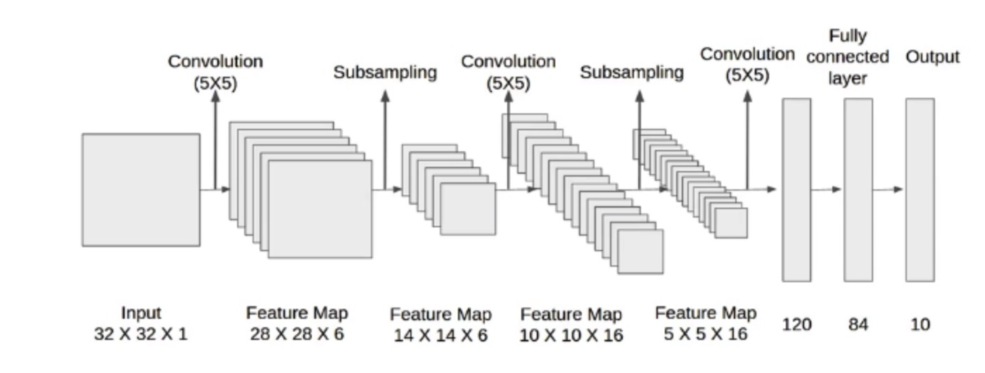

MODULE DESCRIPTION:
IMPORT THE GIVEN IMAGE FROM DATASET:

We have to import our data set using keras preprocessing image data generator function also we create size, rescale, range, zoom range, horizontal flip. Then we import our image dataset from folder through the data generator function. Here we set train, test, and validation also we set target size, batch size and class-mode from this function we have to train using our own created network by adding layers of CNN.

TO TRAIN THE MODULE BY GIVEN IMAGE DATASET:
To train our dataset using classifier and fit generator function also we make training steps per epoch’s then total number of epochs, validation data and validation steps using this data we can train our dataset.

WORKING PROCESS OF LAYERS IN CNN MODEL:
A Convolutional Neural Network (ConvNet/CNN) is a Deep Learning algorithm which can take in an input image, assign importance (learnable weights and biases) to various aspects/objects in the image and be able to differentiate one from the other. The pre-processing required in a ConvNet is much lower as compared to other classification algorithms. While in primitive methods filters are hand-engineered, with enough training, ConvNets have the ability to learn these filters/characteristics. The architecture of a ConvNet is analogous to that of the connectivity pattern of Neurons in the Human disease and was inspired by the organization of the Visual Cortex. Individual neurons respond to stimuli only in a restricted region of the visual field known as the Receptive Field. Their network consists of four layers with 1,024 input units, 256 units in the first hidden layer, eight units in the second hidden layer, and two output units.
Input Layer:
Input layer in CNN contain image data. Image data is represented by three dimensional matrixes. It needs to reshape it into a single column. Suppose you have image of dimension 28 x 28 =784, it need to convert it into 784 x 1 before feeding into input.

Convo Layer:
Convo layer is sometimes called feature extractor layer because features of the image are get extracted within this layer. First of all, a part of image is connected to Convo layer to perform convolution operation as we saw earlier and calculating the dot product between receptive field (it is a local region of the input image that has the same size as that of filter) and the filter. Result of the operation is single integer of the output volume. Then the filter over the next receptive field of the same input image by a Stride and do the same operation again. It will repeat the same process again and again until it goes through the whole image. The output will be the input for the next layer.
Pooling Layer:
Pooling layer is used to reduce the spatial volume of input image after convolution. It is used between two convolution layers. If it applies FC after Convo layer without applying pooling or max pooling, then it will be computationally expensive. So, the max pooling is only way to reduce the spatial volume of input image. It has applied max pooling in single depth slice with Stride of 2. It can observe the 4 x 4 dimension input is reducing to 2 x 2 dimensions.

Fully Connected Layer (FC):
Fully connected layer involves weights, biases, and neurons. It connects neurons in one layer to neurons in another layer. It is used to classify images between different categories by training.

Softmax / Logistic Layer:
Softmax or Logistic layer is the last layer of CNN. It resides at the end of FC layer. Logistic is used for binary classification and softmax is for multi-classification.

Output Layer:
Output layer contains the label which is in the form of one-hot encoded. Now you have a good understanding of CNN.

Given dataset

Diagnosis of
diabetes
Feature Extractions

CNN Model

Input image

The diagnosis of diabetes parts recognition method is based on a two-channel architecture that is able to recognize the parts. The diabetes are cropped and extracted and then used as the input into the inception layer of the CNN. The Training phase involves the feature extraction and classification using convolution neural network.

Libraries Required:
- tensorflow: Just to use the tensor board to compare the loss and adam curve our result data or obtained log.
- keras: To pre-process the image dataset.
- matplotlib: To display the result of our predictive outcome.
- os: To access the file system to read the image from the train and test directory from our machines.

TensorFlow:
TensorFlow is a Python library for fast numerical computing created and released by Google. It is a foundation library that can be used to create Deep Learning models directly or by using wrapper libraries that simplify the process built on top of TensorFlow.
TensorFlow is a software library or framework, designed by the Google team to implement machine learning and deep learning concepts in the easiest manner. It combines the computational algebra of optimization techniques for easy calculation of many mathematical expressions.
Let us now consider the following important features of TensorFlow −
- It includes a feature of that defines, optimizes and calculates mathematical expressions easily with the help of multi-dimensional arrays called tensors.
- It includes a programming support of deep neural networks and machine learning techniques.
- It includes a high scalable feature of computation with various data sets.
- TensorFlow uses GPU computing, automating management. It also includes a unique feature of optimization of same memory and the data used.

Keras:
Keras runs on top of open source machine libraries like TensorFlow, Theano or Cognitive Toolkit (CNTK). Theano is a python library used for fast numerical computation tasks. TensorFlow is the most famous symbolic math library used for creating neural networks and deep learning models. TensorFlow is very flexible and the primary benefit is distributed computing. CNTK is deep learning framework developed by Microsoft. It uses libraries such as Python, C#, C++ or standalone machine learning toolkits. Theano and TensorFlow are very powerful libraries but difficult to understand for creating neural networks.
Keras is based on minimal structure that provides a clean and easy way to create deep learning models based on TensorFlow or Theano. Keras is designed to quickly define deep learning models. Well, Keras is an optimal choice for deep learning applications.

Features
Keras leverages various optimization techniques to make high level neural network API easier and more performant. It supports the following features −
- Consistent, simple and extensible API.
- Minimal structure - easy to achieve the result without any frills.
- It supports multiple platforms and backends.
- It is user friendly framework which runs on both CPU and GPU.
- Highly scalability of computation.
Matplotlib:
Matplotlib is one of the most popular Python packages used for data visualization. It is a cross-platform library for making 2D plots from data in arrays. Matplotlib is written in Python and makes use of NumPy, the numerical mathematics extension of Python. It provides an object-oriented API that helps in embedding plots in applications using Python GUI toolkits such as PyQt, WxPythonotTkinter. It can be used in Python and IPython shells, Jupyter notebook and web application servers also.
Matplotlib has a procedural interface named the Pylab, which is designed to resemble MATLAB, a proprietary programming language developed by MathWorks. Matplotlib along with NumPy can be considered as the open source equivalent of MATLAB.
Os:
The OS module in Python comes with various functions that enables developers to interact with the Operating system that they are currently working on. In this article we’ll be learning mainly to create and delete a directory/folder, rename a directory and even basics of file handling.
Python OS module provides the facility to establish the interaction between the user and the operating system. It offers many useful OS functions that are used to perform OS-based tasks and get related information about operating system.
The OS comes under Python's standard utility modules. This module offers a portable way of using operating system dependent functionality.

DEPLOY:
DEPLOY
Deploying the model in Django Framework and predicting output
In this module the trained deep learning model is converted into hierarchical data format file (.h5 file) which is then deployed in our django framework for providing better user interface and predicting the output.

Django (Web FrameWork) :

Django is a micro web framework written in Python.
It is classified as a micro-framework because it does not require particular tools or libraries.
It has no database abstraction layer, form validation, or any other components where pre-existing third-party libraries provide common functions.
However, Django supports extensions that can add application features as if they were implemented in Django itself.
Extensions exist for object-relational mappers, form validation, upload handling, various open authentication technologies and several common framework related tools.
Django was created by Armin Ronacher of Pocoo, an international group of Python enthusiasts formed in 2004. According to Ronacher, the idea was originally an April Fool’s joke that was popular enough to make into a serious application. The name is a play on the earlier Bottle framework.
When Ronacher and Georg Brand created a bulletin board system written in Python, the Pocoo projects Werkzeug and Jinja were developed.
In April 2016, the Pocoo team was disbanded and development of Django and related libraries passed to the newly formed Pallets project.
Django has become popular among Python enthusiasts. As of October 2020, it has second most stars on GitHub among Python web-development frameworks, only slightly behind Django, and was voted the most popular web framework in the Python Developers Survey 2018.
The micro-framework Django is part of the Pallets Projects, and based on several others of them.

Django is based on Werkzeug, Jinja2 and inspired by Sinatra Ruby framework, available under BSD licence. It was developed at pocoo by Armin Ronacher. Although Django is rather young compared to most Python frameworks, it holds a great promise and has already gained popularity among Python web developers. Let’s take a closer look into Django, so-called “micro” framework for Python.

FEATURES:
Django was designed to be easy to use and extend. The idea behind Django is to build a solid foundation for web applications of different complexity. From then on you are free to plug in any extensions you think you need. Also you are free to build your own modules. Django is great for all kinds of projects. It's especially good for prototyping. Django depends on two external libraries: the Jinja2 template engine and the Werkzeug WSGI toolkit.
Still the question remains why use Django as your web application framework if we have immensely powerful Django, Pyramid, and don’t forget web mega-framework Turbo-gears? Those are supreme Python web frameworks BUT out-of-the-box Django is pretty impressive too with it’s:
- Built-In Development server and Fast debugger
- integrated support for unit testing
- RESTful request dispatching
- Uses Jinja2 Templating
- support for secure cookies
- Unicode based
- Extensive Documentation
- Google App Engine Compatibility
- Extensions available to enhance features desired

Plus Django gives you so much more CONTROL on the development stage of your project. It follows the principles of minimalism and let you decide how you will build your application.
- Django has a lightweight and modular design, so it easy to transform it to the web framework you need with a few extensions without weighing it down
- ORM-agnostic: you can plug in your favourite ORM e.g. SQLAlchemy.
- Basic foundation API is nicely shaped and coherent.
- Django documentation is comprehensive, full of examples and well structured. You can even try out some sample application to really get a feel of Django.
- It is super easy to deploy Django in production (Django is 100% WSGI 1.0 compliant”)
- HTTP request handling functionality
- High Flexibility
The configuration is even more flexible than that of Django, giving you plenty of solution for every production need.
To sum up, Django is one of the most polished and feature-rich micro frameworks, available. Still young, Django has a thriving community, first-class extensions, and an elegant API. Django comes with all the benefits of fast templates, strong WSGI features, thorough unit testability at the web application and library level, extensive documentation. So next time you are starting a new project where you need some good features and a vast number of extensions, definitely check out Django.
Django is an API of Python that allows us to build up web-applications. It was developed by Armin Ronacher. Django's framework is more explicit than Django framework and is also easier to learn because it has less base code to implement a simple web-Application
Django is a micro web framework written in Python. It is classified as a micro-framework because it does not require particular tools or libraries. It has no database abstraction layer, form validation, or any other components where pre-existing third-party libraries provide common functions.
Overview of Python Django Framework Web apps are developed to generate content based on retrieved data that changes based on a user’s interaction with the site. The server is responsible for querying, retrieving, and updating data. This makes web applications to be slower and more complicated to deploy than static websites for simple applications.
Django is an excellent web development framework for REST API creation. It is built on top of Python which makes it powerful to use all the python features.
Django is used for the backend, but it makes use of a templating language called Jinja2 which is used to create HTML, XML or other markup formats that are returned to the user via an HTTP request.
Django is considered to be more popular because it provides many out of box features and reduces time to build complex applications. Django is a good start if you are getting into web development. Django is a simple, un-opinionated framework; it doesn't decide what your application should look like developers do.
Django is a web framework. This means Django provides you with tools, libraries and technologies that allow you to build a web application. This web application can be some web pages, a blog, and a wiki or go as big as a web-based calendar application or a commercial website.

Advantages of Django:
- Higher compatibility with latest technologies.
- Technical experimentation.
- Easier to use for simple cases.
- Codebase size is relatively smaller.
- High scalability for simple applications.
- Easy to build a quick prototype.
- Routing URL is easy.
- Easy to develop and maintain applications.

Framework Django is a web framework from Python language. Django provides a library and a collection of codes that can be used to build websites, without the need to do everything from scratch. But Framework Django still doesn't use the Model View Controller (MVC) method.
Django-RESTful is an extension for Django that provides additional support for building REST APIs. You will never be disappointed with the time it takes to develop an API. Django-Restful is a lightweight abstraction that works with the existing ORM/libraries. Django-RESTful encourages best practices with minimal setup.

Django Restful is an extension for Django that adds support for building REST APIs in Python using Django as the back-end. It encourages best practices and is very easy to set up. Django restful is very easy to pick up if you're already familiar with Django.
Django is a web framework for Python, meaning that it provides functionality for building web applications, including managing HTTP requests and rendering templates and also we can add to this application to create our API.

Start Using an API
- Most APIs require an API key. ...
- The easiest way to start using an API is by finding an HTTP client online, like REST-Client, Postman, or Paw.
- The next best way to pull data from an API is by building a URL from existing API documentation.

The Django object implements a WSGI application and acts as the central object. It is passed the name of the module or package of the application. Once it is created it will act as a central registry for the view functions, the URL rules, template configuration and much more.
The name of the package is used to resolve resources from inside the package or the folder the module is contained in depending on if the package parameter resolves to an actual python package (a folder with an __init__.py file inside) or a standard module (just a .py file).
For more information about resource loading, see open resource().
Usually you create a Django instance in your main module or in the __init__.py file of your package.

Parameters
- rule (str) – The URL rule string.
- endpoint (Optional[str]) – The endpoint name to associate with the rule and view function. Used when routing and building URLs. Defaults to view_func.__name__.
- view_func (Optional[Callable]) – The view function to associate with the endpoint name.
- provide_automatic_options (Optional[bool]) – Add the OPTIONS method and respond to OPTIONS requests automatically.
- options (Any) – Extra options passed to the Rule object.
Return type -- None

After_Request(f)
Register a function to run after each request to this object.
The function is called with the response object, and must return a response object. This allows the functions to modify or replace the response before it is sent.
If a function raises an exception, any remaining after request functions will not be called. Therefore, this should not be used for actions that must execute, such as to close resources. Use teardown_request() for that.
Parameters:
f (Callable[[Response], Response])
Return type
Callable[[Response], Response]
after_request_funcs: t.Dict[AppOrBlueprintKey,
t.List[AfterRequestCallable]]
A data structure of functions to call at the end of each request, in the format {scope: [functions]}. The scope key is the name of a blueprint the functions are active for, or None for all requests.
To register a function, use the after_request() decorator.
This data structure is internal. It should not be modified directly and its format may change at any time.
app_context()
Create an AppContext. Use as a with block to push the context, which will make current_app point at this application.
An application context is automatically pushed by RequestContext.push() when handling a request, and when running a CLI command. Use this to manually create a context outside of these situations.
With app.app_context():
Init_db()

HTML

HTML stands for Hyper Text Markup Language. It is used to design web pages using a markup language. HTML is the combination of Hypertext and Markup language. Hypertext defines the link between the web pages. A markup language is used to define the text document within tag which defines the structure of web pages. This language is used to annotate (make notes for the computer) text so that a machine can understand it and manipulate text accordingly. Most markup languages (e.g. HTML) are human-readable. The language uses tags to define what manipulation has to be done on the text.

Basic Construction of an HTML Page
These tags should be placed underneath each other at the top of every HTML page that you create.
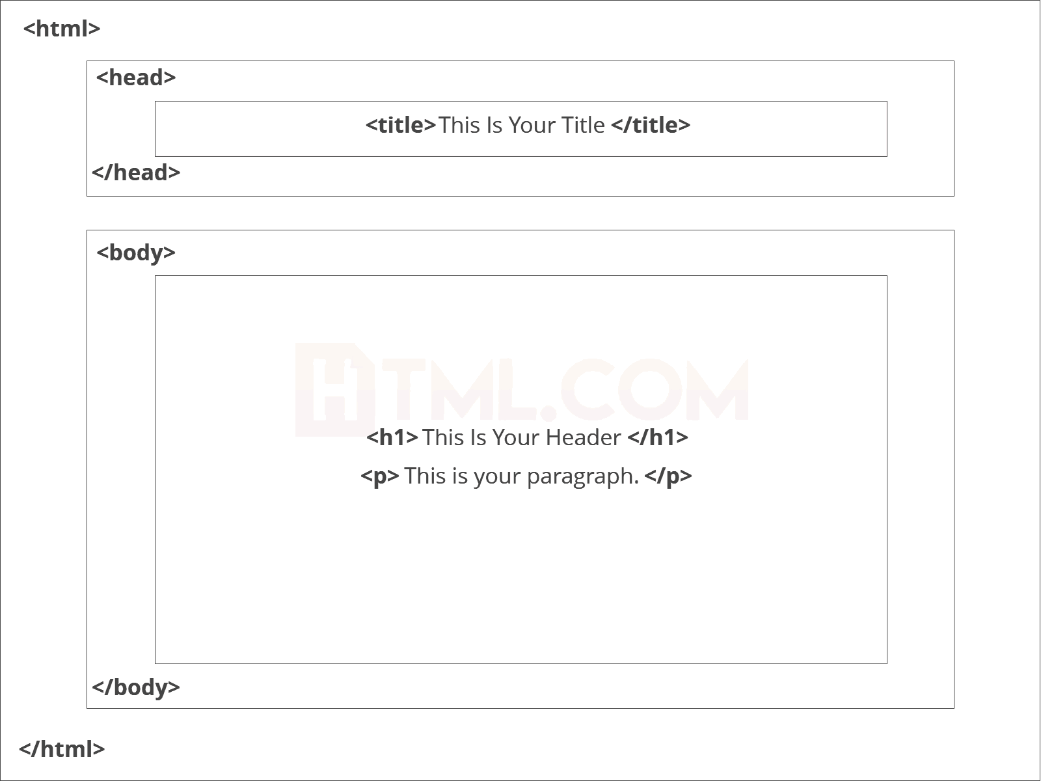

<!DOCTYPE html> — This tag specifies the language you will write on the page. In this case, the language is HTML 5.
<html> — This tag signals that from here on we are going to write in HTML code.
<head> — This is where all the metadata for the page goes — stuff mostly meant for search engines and other computer programs.
<body> — This is where the content of the page goes.

Further Tags
Inside the <head> tag, there is one tag that is always included: <title>, but there are others that are just as important:

<title>
This is where we insert the page name as it will appear at the top of the browser window or tab.
<meta>
This is where information about the document is stored: character encoding, name (page context), description.

Head Tag
<head>
<title>My First Webpage</title>
<meta charset="UTF-8">
<meta name="description" content="This field contains information about your page. It is usually around two sentences long.">.
<meta name="author" content="Conor Sheils">
</header>

Adding Content
Next, we will make<body> tag.
The HTML <body> is where we add the content which is designed for viewing by human eyes.
This includes text, images, tables, forms and everything else that we see on the internet each day.

Add HTML Headings To Web Page
In HTML, headings are written in the following elements:
- <h1>
- <h2>
- <h3>
- <h4>
- <h5>
- <h6>

As you might have guessed <h1> and <h2> should be used for the most important titles, while the remaining tags should be used for sub-headings and less important text.
Search engine bots use this order when deciphering which information is most important on a page.

Creating Your Heading
Let’s try it out. On a new line in the HTML editor, type:
<h1> Welcome To My Page </h1>
And hit save. We will save this file as “index.html” in a new folder called “my webpage.”

Add Text In HTML
Adding text to our HTML page is simple using an element opened with the tag <p> which creates a new paragraph. We place all of our regular text inside the element <p>.
When we write text in HTML, we also have a number of other elements we can use to control the text or make it appear in a certain way.

Add Links In HTML
As you may have noticed, the internet is made up of lots of links.
Almost everything you click on while surfing the web is a link takes you to another page within the website you are visiting or to an external site.
Links are included in an attribute opened by the <a> tag. This element is the first that we’ve met which uses an attribute and so it looks different to previously mentioned tags.

<a href=http://www.google.com>Google</a>

Image Tag
In today’s modern digital world, images are everything. The <img> tag has everything you need to display images on your site. Much like the <a> anchor element, <img> also contains an attribute.
The attribute features information for your computer regarding the source, height, width and alt text of the image
<img src=”yourimage.jpg” alt=”Describe the image” height=“X” width=“X”>

CSS
CSS stands for Cascading Style Sheets. It is the language for describing the presentation of Web pages, including colours, layout, and fonts, thus making our web pages presentable to the users.CSS is designed to make style sheets for the web. It is independent of HTML and can be used with any XML-based markup language. Now let’s try to break the acronym:
- Cascading: Falling of Styles
- Style: Adding designs/Styling our HTML tags
- Sheets: Writing our style in different documents

CSS Syntax
Selector {
Property 1 : value;
Property 2 : value;
Property 3 : value;
}
For example:
h1
{
Color: red;
Text-align: center;
}
#unique
{
color: green;
}

- Selector: selects the element you want to target
- Always remains the same whether we apply internal or external styling
- There are few basic selectors like tags, id’s, and classes
- All forms this key-value pair
- Keys: properties(attributes) like color, font-size, background, width, height,etc
- Value: values associated with these properties

CSS Comment
- Comments don’t render on the browser
- Helps to understand our code better and makes it readable.
- Helps to debug our code
- Two ways to comment:
  - Single line

CSS How-To
- There are 3 ways to write CSS in our HTML file.
  - Inline CSS
  - Internal CSS
  - External CSS
- Priority order
  - Inline > Internal > External

Inline CSS
- Before CSS this was the only way to apply styles
- Not an efficient way to write as it has a lot of redundancy
- Self-contained
- Uniquely applied on each element
- The idea of separation of concerns was lost
- Example:
<h3 style = “color:red”> Have a great day </h3>
<p style = “color:green”> I did this, I did that </p>

Internal CSS
- With the help of style tag, we can apply styles within the HTML file
- Redundancy is removed
- But the idea of separation of concerns still lost
- Uniquely applied on a single document
- Example:
<style>
H1{
Color:red;
}
</style>
<h3> Have a great day </h3>

External CSS
- With the help of <link> tag in the head tag, we can apply styles
- Reference is added
- File saved with .css extension
- Redundancy is removed
- The idea of separation of concerns is maintained
- Uniquely applied to each document
- Example:

<head>
<link rel= “stylesheet” type= “text/css” href= “name of the CSS file”>
</head>
h1{
color:red; //.css file
}

CSS Selectors
- The selector is used to target elements and apply CSS
- Three simple selectors
  - Element Selector
  - Id Selector
  - Class Selector
- Priority of Selectors

CSS Colors
- There are different colouring schemes in CSS
- RGB-This starts with RGB and takes 3 parameter
- HEX-Hex code starts with # and comprises of 6 numbers which are further divided into 3 sets
- RGBA-This starts with RGB and takes 4 parameter

CSS Background
- There are different ways by which CSS can have an effect on HTML elements
- Few of them are as follows:
  - Color – used to set the color of the background
  - Repeat – used to determine if the image has to repeat or not and if it is repeating then how it should do that
  - Image – used to set an image as the background
  - Position – used to determine the position of the image
  - Attachment – It basically helps in controlling the mechanism of scrolling.

CSS BoxModel
- Every element in CSS can be represented using the BOX model
- It allows us to add a border and define space between the content
- It helps the developer to develop and manipulate the elements
- It consists of 4 edges
  - Content edge – It comprises of the actual content
  - Padding edge – It lies in between content and border edge
  - Border edge – Padding is followed by the border edge
  - Margin edge – It is an outside border and controls the margin of the element

CODE:
MODULE 1:
# MANUAL NET ARCHITECTURE
import warnings
warnings.filterwarnings('ignore')
import os
import glob
import numpy as np

from tensorflow.keras.preprocessing.image import ImageDataGenerator

from tensorflow.keras.models import Sequential
from PIL import Image

from tensorflow.keras.layers import Convolution2D
from tensorflow.keras.layers import MaxPooling2D
from tensorflow.keras.layers import Flatten
from tensorflow.keras.layers import Dense
from tensorflow.keras.layers import Activation

from keras.callbacks import ModelCheckpoint
import matplotlib.pyplot as plt
Mild = 'dataset/train/Mild'
Moderate = 'dataset/train/Moderate'
No_DR = 'dataset/train/No_DR'
Proliferate_DR = 'dataset/train/Proliferate_DR'
Severe = 'dataset/train/Severe'
def plot_images(item_dir, n=6):
all_item_dir = os.listdir(item_dir)
item_files = [os.path.join(item_dir, file) for file in all_item_dir][:n]

plt.figure(figsize=(80, 40))
for idx, img_path in enumerate(item_files):
plt.subplot(3, n, idx+1)
img = plt.imread(img_path)
plt.imshow(img, cmap='gray')
plt.axis('off')

plt.tight_layout()

def image_details_print(data,path):
print('======== Images in: ', path)
for key,values in data.items():
print(key,':\t', values)

def images_details(path):
files=[f for f in glob.glob(path + "**/*.*", recursive=True)]
data={}
data['Images_count']=len(files)
data['Min_width']=10**100
data['Max_width']=0
data['Min_height']=10**100
data['Max_height']=0

for f in files:
img=Image.open(f)
width,height=img.size
data['Min_width']=min(width,data['Min_width'])
data['Max_width']=max(width, data['Max_width'])
data['Min_height']=min(height, data['Min_height'])
data['Max_height']=max(height, data['Max_height'])

image_details_print(data,path)
print("")
print("TRAINING DATA FOR Mild:")
print("")
images_details(Mild)
print("")
plot_images(Mild, 10)

print("")
print("TRAINING DATA FOR Moderate:")
print("")
images_details(Moderate)
print("")
plot_images(Moderate, 10)
print("")
print("TRAINING DATA FOR No_DR:")
print("")
images_details(No_DR)
print("")
plot_images(No_DR, 10)
print("")
print("TRAINING DATA FOR Proliferate_DR:")
print("")
images_details(Proliferate_DR)
print("")
plot_images(Proliferate_DR, 10)
print("")
print("TRAINING DATA FOR Severe:")
print("")
images_details(Severe)
print("")
plot_images(Severe, 10)
train_datagen=ImageDataGenerator(rescale=1./255,shear_range=0.2,zoom_range=0.2,horizontal_flip=True)
training_set=train_datagen.flow_from_directory('dataset/train',target_size=(224,224),batch_size=32,class_mode='categorical')
test_datagen=ImageDataGenerator(rescale=1./255)
test_set=test_datagen.flow_from_directory('dataset/test',target_size=(224,224),batch_size=32,class_mode='categorical')
Classifier=Sequential()
Classifier.add(Convolution2D(32,(3,3),input_shape=(224,224,3),activation='relu'))
Classifier.add(MaxPooling2D(pool_size=(2,2)))
Classifier.add(Flatten())
Classifier.add(Dense(38, activation='relu'))
Classifier.add(Dense(5, activation='softmax'))
Classifier.compile(optimizer='rmsprop',loss='categorical_crossentropy',metrics=['accuracy'])
model_path = "MANUAL.h5"

callbacks = [
ModelCheckpoint(model_path, monitor='accuracy', verbose=1, save_best_only=True)
]
epochs = 10
batch_size = 512
#### Fitting the model
history = Classifier.fit(
training_set, steps_per_epoch=training_set.samples // batch_size,
epochs=epochs,
validation_data=test_set,validation_steps=test_set.samples // batch_size,
callbacks=callbacks)
import matplotlib.pyplot as plt

def graph():
#Plot training & validation accuracy values
plt.plot(history.history['accuracy'])
plt.plot(history.history['val_accuracy'])
plt.title('Model accuracy')
plt.ylabel('Accuracy')
plt.xlabel('Epoch')
plt.legend(['Train', 'Test'], loc='upper left')
plt.show()

graph()
import matplotlib.pyplot as plt

def graph():
plt.plot(history.history['loss'])
plt.plot(history.history['val_loss'])
plt.title('Model loss')
plt.ylabel('Loss')
plt.xlabel('Epoch')
plt.legend(['Train', 'Test'], loc='upper left')
plt.show()
graph()

MODULE 2:
# LENET ARCHITECTURE
import warnings
warnings.filterwarnings('ignore')

# import os
# os.environ['KMP_DUPLICATE_LIB_OK']="TRUE"
import tensorflow
import tensorflow as tf
print(tf.__version__)

from tensorflow.keras.models import Sequential

from tensorflow.keras.layers import Conv2D
from tensorflow.keras.layers import Convolution2D
from tensorflow.keras.layers import MaxPool2D
from tensorflow.keras.layers import MaxPooling2D
from tensorflow.keras.layers import Flatten
from tensorflow.keras.layers import Dense
from tensorflow.keras.layers import Dropout
from tensorflow.keras.layers import Activation
from tensorflow.keras.preprocessing.image import ImageDataGenerator

train=ImageDataGenerator(rescale=1./255,shear_range=0.2,zoom_range=0.2,horizontal_flip=True,validation_split = 0.2)
train_data=train.flow_from_directory(directory = 'dataset/train',target_size=(224,224),
batch_size=32,class_mode='categorical')
test=ImageDataGenerator(rescale=1./255)
test_data=test.flow_from_directory(directory = 'dataset/test',target_size=(224,224),
batch_size=32,class_mode='categorical')
MODEL=Sequential()
MODEL.add(Convolution2D(filters=32, kernel_size=(3,3), strides=(3,3), input_shape=(224,224,3), padding=('valid'), activation='relu'))
MODEL.add(MaxPooling2D(pool_size=(2,2), strides=(2,2), padding='valid'))
MODEL.add(Convolution2D(filters=128, kernel_size=(3,3), strides=(3,3), padding=('valid'), activation='relu'))
MODEL.add(MaxPooling2D(pool_size=(2,2), strides=(2,2), padding='valid'))
MODEL.add(Flatten())
MODEL.add(Dense(256, activation='relu'))
MODEL.add(Dense(5, activation='softmax'))

OPT = tensorflow.keras.optimizers.Adam(0.001)

MODEL.compile(optimizer=OPT,loss='categorical_crossentropy',metrics=["accuracy", tensorflow.keras.metrics.Precision(), tensorflow.keras.metrics.Recall()])
MODEL.summary()
model_path = "LENET.h5"

from tensorflow.keras.callbacks import ModelCheckpoint

M = ModelCheckpoint(model_path, monitor='accuracy', verbose=1, save_best_only=True, mode='max')
epochs = 200
batch_size = 32
WORKING = MODEL.fit_generator(
train_data, steps_per_epoch=train_data.samples // batch_size,
epochs=epochs,
validation_data=test_data,validation_steps=test_data.samples // batch_size,
callbacks=[M])
WORKING.history.keys()

import matplotlib.pyplot as plt
import numpy as np

plt.figure(figsize=(20, 8))
plt.plot(WORKING.history['accuracy'])

for i in range(epochs):
if i%5 == 0:
plt.annotate(np.round(WORKING.history['accuracy'][i]*100,2),xy=(i,WORKING.history['accuracy'][i]))

plt.title('Model accuracy')
plt.ylabel('Accuracy')
plt.xlabel('Epoch')
plt.show()
import matplotlib.pyplot as plt

plt.figure(figsize=(20, 8))
plt.plot(WORKING.history['loss'])

for i in range(epochs):
if i%5 == 0:
plt.annotate(np.round(WORKING.history['loss'][i]*100,2),xy=(i,WORKING.history['loss'][i]))

plt.title('Model Loss')
plt.ylabel('Loss')
plt.xlabel('Epoch')
plt.show()

MODULE 3:
## DATA PREPROCESSING AND DATA CLEANING
import pandas as pd
import numpy as np

import warnings
warnings.filterwarnings('ignore')
df = pd.read_csv('DIABETICS.csv')
df.head()
df.tail()
df.shape
df.size
df.columns
df.isnull()
df = df.dropna()
df['class'].value_counts()
from sklearn.preprocessing import LabelEncoder
le = LabelEncoder()

var = ['Gender', 'Polyuria', 'Polydipsia', 'sudden weight loss',
'weakness', 'Polyphagia', 'Genital thrush', 'visual blurring',
'Itching', 'Irritability', 'delayed healing', 'partial paresis',
'muscle stiffness', 'Alopecia', 'Obesity', 'class']

for i in var:
df[i] = le.fit_transform(df[i]).astype(int)
df['class'].value_counts()
df.describe()
df.info()
df.corr()
pd.Categorical(df["Irritability"]).describe()
df.duplicated()
df = df.drop_duplicates()
sum(df.duplicated())

MODULE 4:
## DATA VISUALIZATION AND DATA ANALYSIS
import pandas as pd
import numpy as np
import matplotlib.pyplot as plt
import seaborn as sns
df = pd.read_csv('DIABETICS.csv')
df.head()
df.columns
df = df.dropna()
df=df.drop_duplicates()
from sklearn.preprocessing import LabelEncoder
le = LabelEncoder()

var = ['Gender', 'Polyuria', 'Polydipsia', 'sudden weight loss',
'weakness', 'Polyphagia', 'Genital thrush', 'visual blurring',
'Itching', 'Irritability', 'delayed healing', 'partial paresis',
'muscle stiffness', 'Alopecia', 'Obesity', 'class']

for i in var:
df[i] = le.fit_transform(df[i]).astype(int)
df.tail()
plt.figure(figsize=(15,5))

plt.subplot(1,2,1)
plt.hist(df['Alopecia'],color='purple')

plt.subplot(1,2,2)
plt.hist(df['Obesity'],color='tomato')

df.hist(figsize=(15,55),layout=(15,4), color='lightblue')
plt.show()
df['class'].hist(figsize=(10,5),color='lightgreen')
plt.scatter(df['Gender'],df['Age'], color='pink') # scatter, plot, triplot, stackplot
plt.boxplot(df['Age'])
sns.boxenplot(df['Alopecia'], color='purple')
# barplot, boxenplot, boxplot, countplot, displot, distplot, ecdfplot, histplot, kdeplot, pointplot, violinplot, stripplot
fig,ax=plt.subplots(figsize=(30,20))
sns.heatmap(df.corr(),annot=True,fmt='0.2%',cmap='autumn',ax=ax)
df['class'].plot(kind='density', color="darkblue")

MODULE 5:
# GRADIENT BOOSTING CLASSIFIER ALGORITHEM
import pandas as pd
import numpy as np
import matplotlib.pyplot as plt
import seaborn as sns

import warnings
warnings.filterwarnings('ignore')
df = pd.read_csv('DIABETICS.csv')
df.head()
df.columns
df=df.dropna()
df.columns
from sklearn.preprocessing import LabelEncoder
le = LabelEncoder()

var = ['Gender', 'Polyuria', 'Polydipsia', 'sudden weight loss',
'weakness', 'Polyphagia', 'Genital thrush', 'visual blurring',
'Itching', 'Irritability', 'delayed healing', 'partial paresis',
'muscle stiffness', 'Alopecia', 'Obesity', 'class']

for i in var:
df[i] = le.fit_transform(df[i]).astype(int)
df.tail()
x1 = df.drop(labels='class', axis=1)
y1 = df.loc[:,'class']
x1
import imblearn
from imblearn.over_sampling import RandomOverSampler
from collections import Counter

ros =RandomOverSampler(random_state=42)
x,y=ros.fit_resample(x1,y1)
print("OUR DATASET COUNT : ", Counter(y1))
print("OVER SAMPLING DATA COUNT : ", Counter(y))
from sklearn.model_selection import train_test_split
x_train, x_test, y_train, y_test = train_test_split(x, y, test_size=0.20, random_state=42, stratify=y)
print("NUMBER OF TRAIN DATASET : ", len(x_train))
print("NUMBER OF TEST DATASET : ", len(x_test))
print("TOTAL NUMBER OF DATASET : ", len(x_train)+len(x_test))
print("NUMBER OF TRAIN DATASET : ", len(y_train))
print("NUMBER OF TEST DATASET : ", len(y_test))
print("TOTAL NUMBER OF DATASET : ", len(y_train)+len(y_test))
from sklearn.ensemble import GradientBoostingClassifier
GRB = GradientBoostingClassifier(random_state=42)
GRB.fit(x_train,y_train)
predicted = GRB.predict(x_test)
from sklearn.metrics import confusion_matrix
cm = confusion_matrix(y_test,predicted)
print('THE CONFUSION MATRIX SCORE OF GRADIENT BOOSTING CLASSIFIER:\n\n\n',cm)
from sklearn.model_selection import cross_val_score
accuracy = cross_val_score(GRB, x, y, scoring='accuracy')
print('THE CROSS VALIDATION TEST RESULT OF ACCURACY :\n\n\n', accuracy*100)
from sklearn.metrics import accuracy_score
a = accuracy_score(y_test,predicted)
print("THE ACCURACY SCORE OF GRADIENT BOOSTING CLASSIFIER IS :",a*100)
from sklearn.metrics import hamming_loss
hl = hamming_loss(y_test,predicted)
print("THE HAMMING LOSS OF GRADIENT BOOSTING CLASSIFIER IS :",hl*100)
from sklearn.metrics import precision_score
P = precision_score(y_test,predicted)
print("THE PRECISION SCORE OF GRADIENT BOOSTING CLASSIFIER IS :",P*100)
from sklearn.metrics import recall_score
R = recall_score(y_test,predicted)
print("THE RECALL SCORE OF GRADIENT BOOSTING CLASSIFIER IS :",R*100)
from sklearn.metrics import f1_score
f1 = f1_score(y_test,predicted)
print("THE PRECISION SCORE OF GRADIENT BOOSTING CLASSIFIER IS :",f1*100)
def plot_confusion_matrix(cm, title='THE CONFUSION MATRIX SCORE OF GRADIENT BOOSTING CLASSIFIER\n\n', cmap=plt.cm.Blues):
target_names=['']
plt.imshow(cm, interpolation='nearest', cmap=cmap)
plt.title(title)
plt.colorbar()
tick_marks = np.arange(len(target_names))
plt.xticks(tick_marks, target_names, rotation=45)
plt.yticks(tick_marks, target_names)
plt.tight_layout()
plt.ylabel('True label')
plt.xlabel('Predicted label')

cm=confusion_matrix(y_test, predicted)
print('THE CONFUSION MATRIX SCORE OF GRADIENT BOOSTING CLASSIFIER:\n\n')
print(cm)

sns.heatmap(cm/np.sum(cm), annot=True, cmap = 'Blues', annot_kws={"size": 16},fmt='.2%')
plt.show()
def graph():
import matplotlib.pyplot as plt
data=[a]
alg=" GRADIENT BOOSTING CLASSIFIER"
plt.figure(figsize=(5,5))
b=plt.bar(alg,data,color=("coral"))
plt.title("THE ACCURACY SCORE OF GRADIENT BOOSTING CLASSIFIER IS\n\n\n")
plt.legend(b,data,fontsize=9)
graph()
import joblib
joblib.dump(GRB, 'DIABETICS.pkl')

MODULE 6:
from django.shortcuts import render, redirect
from django.urls import reverse_lazy
from .forms import UserImageForm
from django.contrib.auth.views import LoginView, PasswordResetView, PasswordChangeView
from django.contrib import messages
from django.contrib.messages.views import SuccessMessageMixin
from django.views import View
from django.contrib.auth.decorators import login_required
from django.contrib.auth import logout as auth_logout
import numpy as np
import joblib
from .forms import RegisterForm, LoginForm, UpdateUserForm, UpdateProfileForm
from django.contrib.auth import authenticate,login,logout
from .models import UserImageModel
import numpy as np
from tensorflow import keras
from PIL import Image,ImageOps

# import pyttsx3
# import time

def home(request):
return render(request, 'users/home.html')

@login_required(login_url='users-register')

def index(request):
return render(request, 'app/index.html')

class RegisterView(View):
form_class = RegisterForm
initial = {'key': 'value'}
template_name = 'users/register.html'

def dispatch(self, request, *args, **kwargs):
# will redirect to the home page if a user tries to access the register page while logged in
if request.user.is_authenticated:
return redirect(to='/')

# else process dispatch as it otherwise normally would
return super(RegisterView, self).dispatch(request, *args, **kwargs)

def get(self, request, *args, **kwargs):
form = self.form_class(initial=self.initial)
return render(request, self.template_name, {'form': form})

def post(self, request, *args, **kwargs):
form = self.form_class(request.POST)

if form.is_valid():
form.save()

username = form.cleaned_data.get('username')
messages.success(request, f'Account created for {username}')

return redirect(to='login')

return render(request, self.template_name, {'form': form})

# Class based view that extends from the built in login view to add a remember me functionality

class CustomLoginView(LoginView):
form_class = LoginForm

def form_valid(self, form):
remember_me = form.cleaned_data.get('remember_me')

if not remember_me:
# set session expiry to 0 seconds. So it will automatically close the session after the browser is closed.
self.request.session.set_expiry(0)

# Set session as modified to force data updates/cookie to be saved.
self.request.session.modified = True

# else browser session will be as long as the session cookie time "SESSION_COOKIE_AGE" defined in settings.py
return super(CustomLoginView, self).form_valid(form)

class ResetPasswordView(SuccessMessageMixin, PasswordResetView):
template_name = 'users/password_reset.html'
email_template_name = 'users/password_reset_email.html'
subject_template_name = 'users/password_reset_subject'
success_message = "We've emailed you instructions for setting your password, " \
"if an account exists with the email you entered. You should receive them shortly." \
" If you don't receive an email, " \
"please make sure you've entered the address you registered with, and check your spam folder."
success_url = reverse_lazy('users-home')

class ChangePasswordView(SuccessMessageMixin, PasswordChangeView):
template_name = 'users/change_password.html'
success_message = "Successfully Changed Your Password"
success_url = reverse_lazy('users-home')

from .models import Profile

def profile(request):
user = request.user
# Ensure the user has a profile
if not hasattr(user, 'profile'):
Profile.objects.create(user=user)

if request.method == 'POST':
user_form = UpdateUserForm(request.POST, instance=request.user)
profile_form = UpdateProfileForm(request.POST, request.FILES, instance=request.user.profile)

if user_form.is_valid() and profile_form.is_valid():
user_form.save()
profile_form.save()
messages.success(request, 'Your profile is updated successfully')
return redirect(to='users-profile')
else:
user_form = UpdateUserForm(instance=request.user)
profile_form = UpdateProfileForm(instance=request.user.profile)

return render(request, 'users/profile.html', {'user_form': user_form, 'profile_form': profile_form})

from . models import UserImageModel
from . import forms
from .forms import UserImageForm

def Deploy_8(request):
print("HI")
if request.method == "POST":
form = forms.UserImageForm(files=request.FILES)
if form.is_valid():
print('HIFORM')
form.save()
obj = form.instance

result1 = UserImageModel.objects.latest('id')
models = keras.models.load_model('D:/prasanna/DL/ITPDL19/CODE/Deploy/Project/App/LENET.h5')
data = np.ndarray(shape=(1, 224, 224, 3), dtype=np.float32)
image = Image.open("D:/prasanna/DL/ITPDL19/CODE/Deploy/Project/media/" + str(result1)).convert("RGB")
size = (224, 224)
image = ImageOps.fit(image, size, Image.ANTIALIAS)
image_array = np.asarray(image)
normalized_image_array = (image_array.astype(np.float32) / 127.0) - 1
data[0] = normalized_image_array
classes = ["Mild","Moderate","No_DR","Proliferate_DR","Severe"]
prediction = models.predict(data)
idd = np.argmax(prediction)
a = (classes[idd])
if a == "Mild":
b ='This Image Detected Mild'
elif a == "Moderate":
b ='This Image Detected Moderate'
elif a == "No_DR":
b ='This Image Detected No_DR'
elif a == "Proliferate_DR":
b ='This Image Detected Proliferate_DR'
elif a == "Severe":
b ='This Image Detected Severe'

else:
b = 'WRONG INPUT'

data = UserImageModel.objects.latest('id')
data.label = a
data.save()

# engine = pyttsx3.init()
# rate = engine.getProperty('rate')
# engine.setProperty('rate', rate - 10) # Decrease rate by 50 (default rate is typically around 200)
# engine.say(a)
# engine.runAndWait()

# text_to_speech(a, delay=7)

return render(request, 'App/output.html',{'form':form,'obj':obj,'predict':a, 'predicted':b})
else:

form = forms.UserImageForm()
return render(request, 'App/model.html',{'form':form})

import joblib

Model = joblib.load('D:/prasanna/DL/ITPDL19/CODE/Deploy/Project/App/DIABETICS.pkl')

from .forms import DiabetesAssessmentfrom
from .models import DiabetesAssessment

def Deploy_9(request):
form = DiabetesAssessmentfrom() # Initialize the form outside the if block

if request.method == 'POST':
form = DiabetesAssessmentfrom(request.POST)

if form.is_valid():
cleaned_data = form.cleaned_data
Age = cleaned_data['Age']
Gender = cleaned_data['Gender']
Polyuria = cleaned_data['Polyuria']
Polydipsia = cleaned_data['Polydipsia']
sudden_weight_loss = cleaned_data['sudden_weight_loss']
weakness = cleaned_data['weakness']
Polyphagia = cleaned_data['Polyphagia']
Genital_thrush = cleaned_data['Genital_thrush']
visual_blurring = cleaned_data['visual_blurring']
Itching = cleaned_data['Itching']
Irritability = cleaned_data['Irritability']
delayed_healing = cleaned_data['delayed_healing']
partial_paresis = cleaned_data['partial_paresis']
muscle_stiffness = cleaned_data['muscle_stiffness']
Alopecia = cleaned_data['Alopecia']
Obesity = cleaned_data['Obesity']

# Create a feature array for prediction
feature = np.array([[
Age, Gender, Polyuria, Polydipsia, sudden_weight_loss,
weakness, Polyphagia, Genital_thrush, visual_blurring,
Itching, Irritability, delayed_healing, partial_paresis,
muscle_stiffness, Alopecia, Obesity
]])

predictions = Model.predict(feature) # Call predict on your model instance

output = predictions[0]

if output == 0:
a = "THE DIABETIC MIGHT NOT BE IN THIS CONDITION."
elif output == 1:
a = "THE DIABETIC MIGHT BE IN THIS CONDITION."

instance = form.save(commit=False)
instance.label = a
instance.save()
print('data saved')

return render(request, 'app/Ml_output.html', {"prediction_text": a})
else:
print('Form is not valid')

return render(request, 'App/9_Deploy.html', {"form": form})

def ML_DB(request):
predictions = DiabetesAssessment.objects.all()
return render(request, 'App/ML_DB.html', {'predictions':predictions })

def Basic(request):
return render(request,'App/Basic_report.html')

def Metrics(request):
return render(request,'App/Metrics_report.html')

def Database(request):
models = UserImageModel.objects.all()
return render(request, 'App/Database.html', {'models': models})

def logout_view(request):
auth_logout(request)
return redirect('/')

SCREENSHOT:

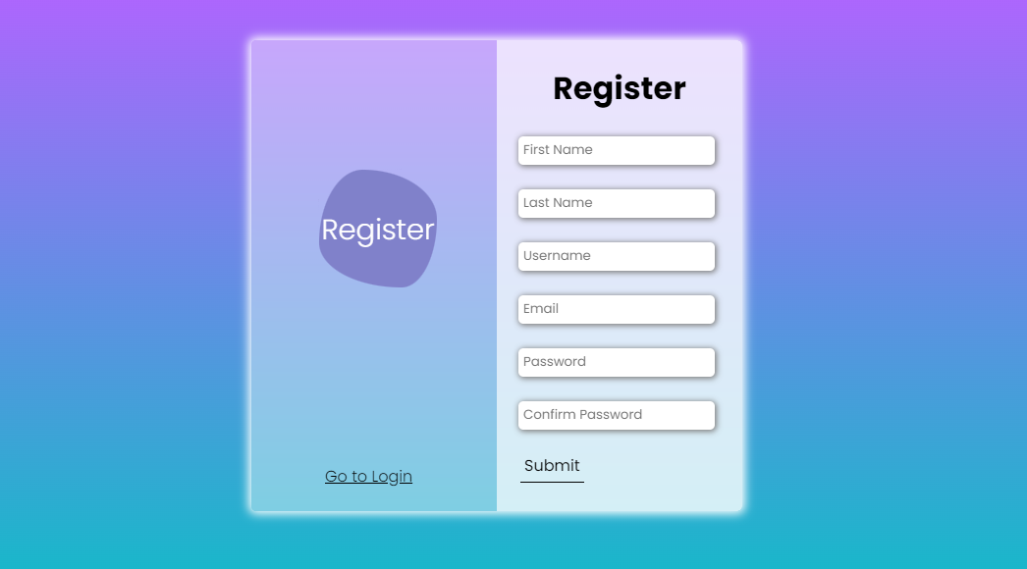

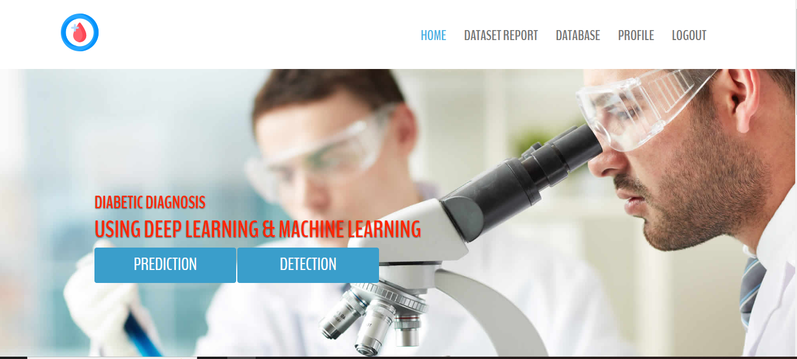
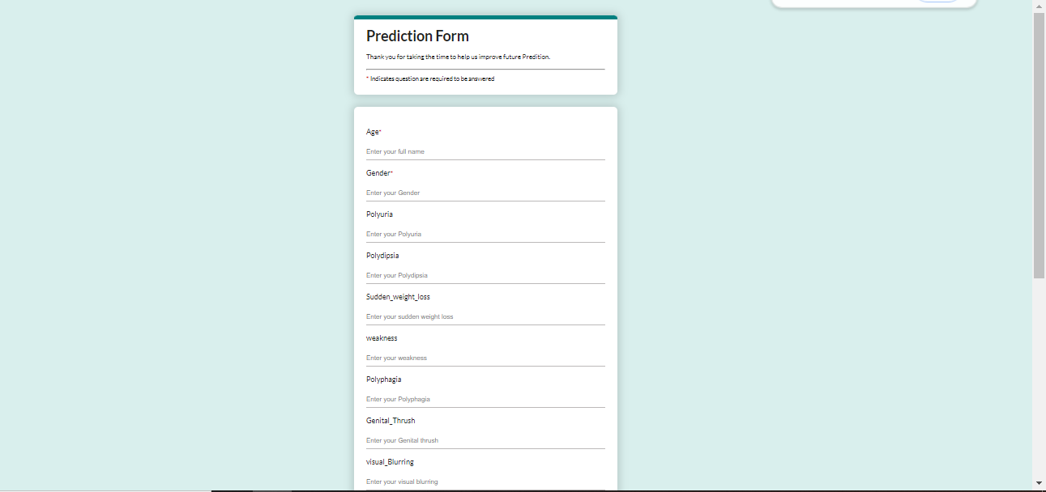
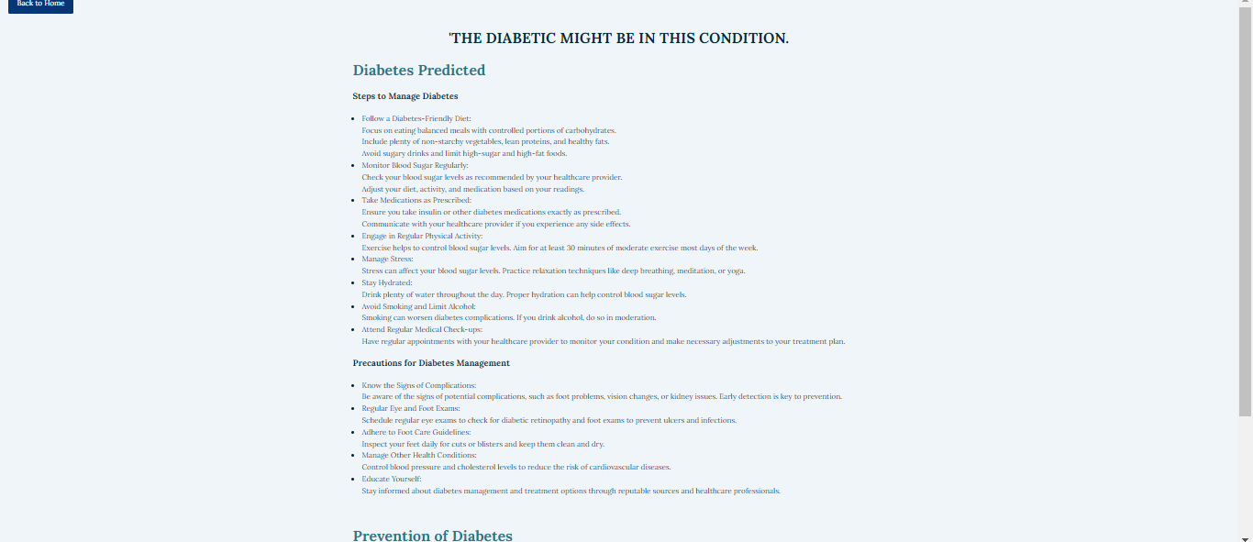


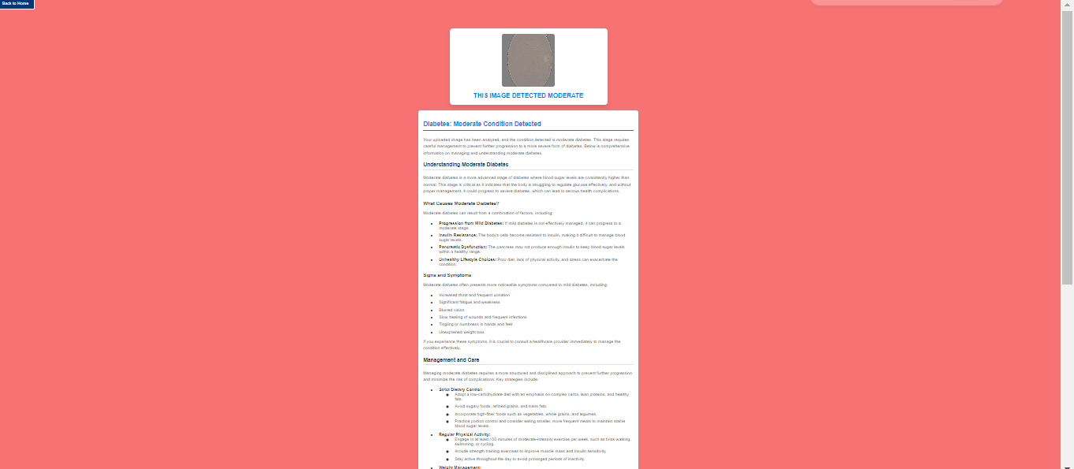
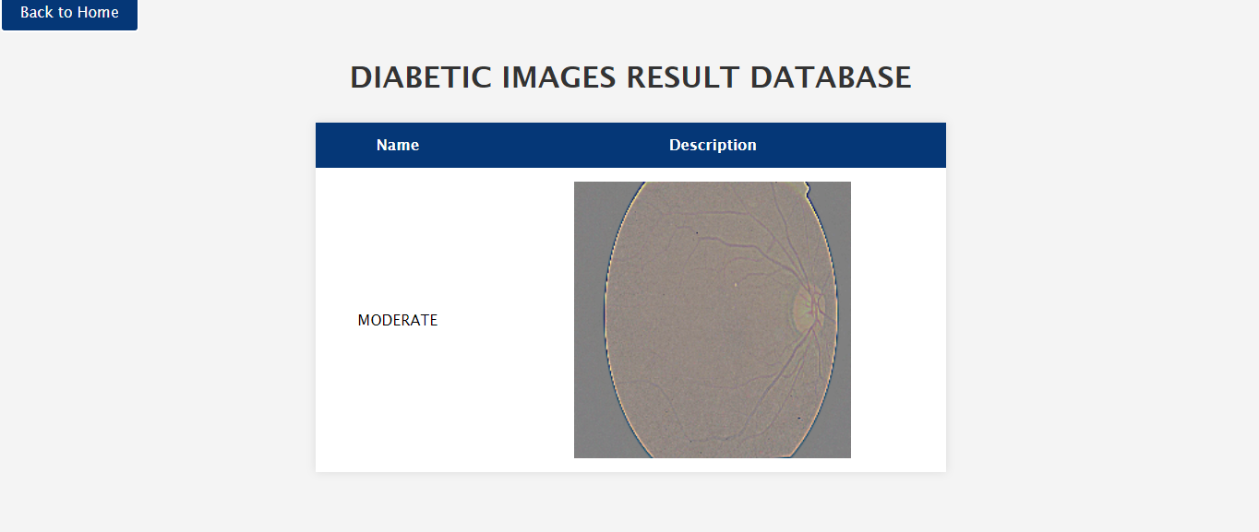

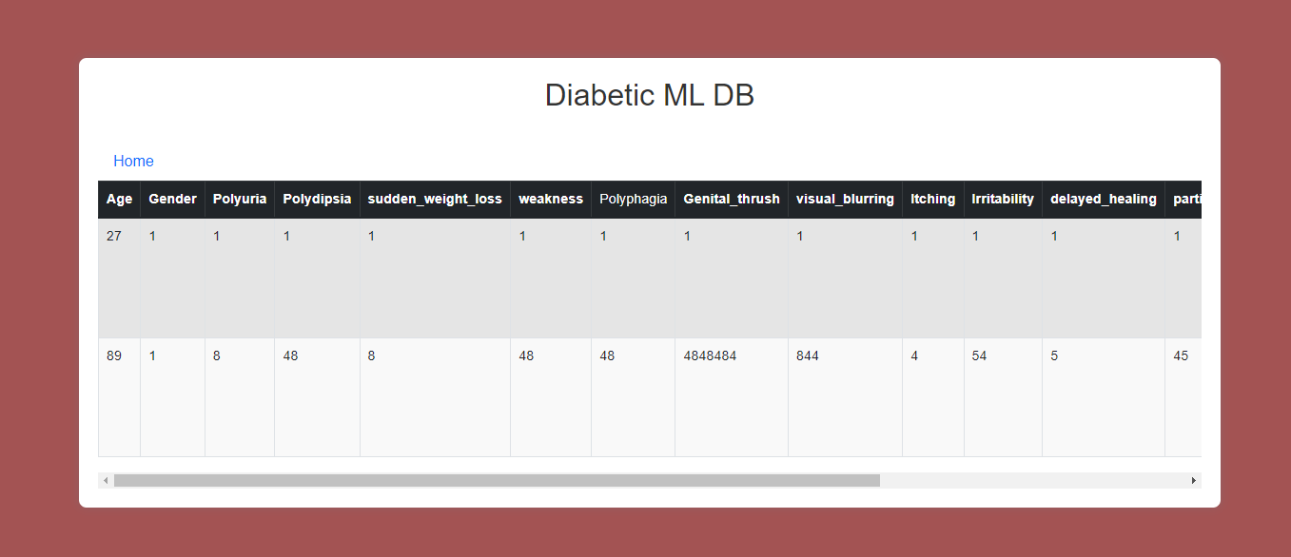
Conclusion:
This project successfully demonstrates the potential of CNN architectures and machine learning in advancing the diagnosis of diabetes. By developing a deep learning model that can accurately analyze medical data, the project contributes to improving early detection and diagnosis. The integration of this model into clinical practice can enhance decision-making, reduce diagnostic errors, and ultimately improve patient outcomes. The results indicate that deep learning, specifically CNNs, can be a valuable tool in the fight against diabetes, offering a more precise and efficient approach to diagnosis.
Future Work:
- We can deploy the model in any cloud-based system.
- We can connect this model to the hardware.

